29 March 2007
NACMA
Boulevard Léopold III
B-1110 Brussels
Belgium
Attn: Mr. George Keith, Programme Manager
Subject: CONTRACT CO-9772-ACCS
Dear Mr. Keith,
ManTech Command Control Systems Corporation (ManTech C2S) respectfully informs you that Mr. Yvan Blomme, NATO Account Manager, has been appointed Contract Programme Manager (CPM) for all activities under subject contract vice Mr. Lindy Martin. This appointment is effective immediately. Mr. Blomme will continue to provide NACMA the outstanding service it has been accustomed to receiving in the past.
Mr. Blomme will be the focal point for all matters related to performance under subject contract and can be reached as follows:
- Telephone: 02.307.0091
- Facsimile: 02.307.0139
- GSM: 0475.709.792
- E-Mail: Yvan.Blomme@ManTech.com
We thank you for the opportunity to support the NACMA team. Should you have any questions, please contact me by telephone in our Brussels office at +32 (0) 2.307.0091, by fax at +32 (0) 2.307.0139, by GSM at +32(0)477.271.117 or via e-mail at Lindy.Martin@ManTech.com.
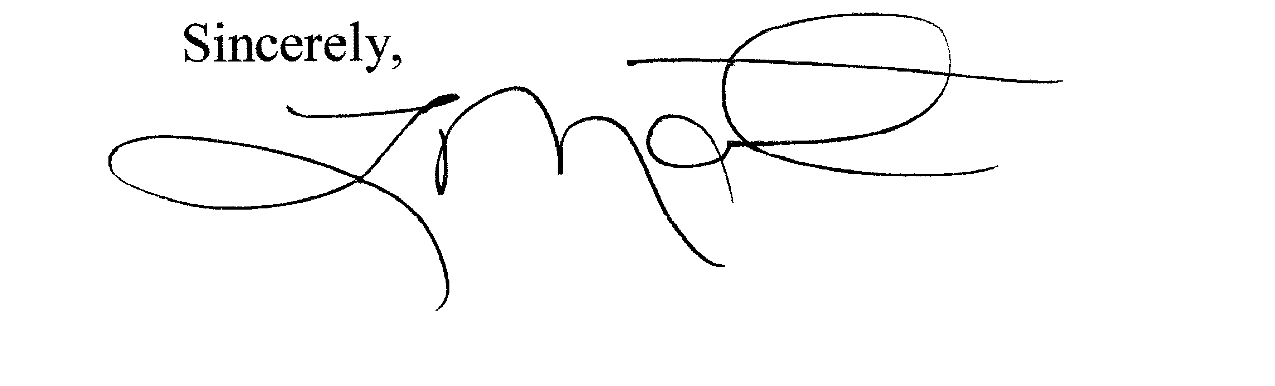
Sincerely,

Lindy Martin
Executive Director
ManTech International Corporation
Command and Control Systems (C2S)

