The following describes how to install, configure and use the Cisco VPN Client to establish a secure, private, and encrypted connection to the ManTech Network.

NOTE: You will need admin rights to your computer to perform the following installation. Close all applications before installing this program. The computer will need to be restarted to complete program installation.

CURRENT VPN USERS: You should uninstall previous versions of the VPN client via Add/Remove Programs before proceeding.

INSTALLATION

- Got to VPN Support Site and download the VPN Client software.

VPN Support Site - https://unite.mantech.com in the Customer Support Center, then VPN Access.

Direct URL - https://unite.mantech.com/C5/VPN%20Access/default.aspx

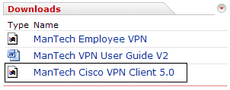

- Double click on ManTech Cisco VPN Client 5.0.exe.

- On the Welcome screen, click Next.

- Accept the license agreement. Click Next.

- On the Destination Folder screen, accept the default location by clicking Next.

- On the Ready to Install screen, click Next to start the installation.

- On the Successfully Installed screen, click on Finish. You will then be prompted to restart your computer. Click on Yes to restart.

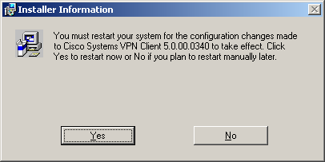

- Start the Cisco VPN Client. Start, All Programs, Cisco Systems VPN Client, VPN Client. The Connection Entry Profile should have been automatically loaded during the client installation and should look like the following –

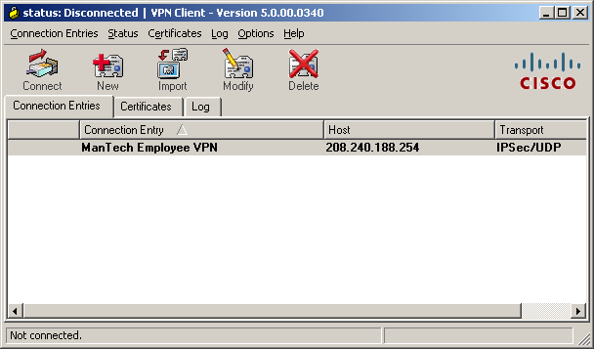

If you see the connection entry, you can skip the CONFIGURATION section and move to USING THE VPN CLIENT. If you do not have a connection entry, please go to the CONFIGURATION section to import the Connection Entry Profile.

CONFIGURATION

If you do not have any Connection Entries, or have been instructed to import a new Connection Entry Profile, perform the following steps.

- Download the Connection Entry Profile - ManTech Employee VPN.pcf from the ManTech VPN Support Site.

VPN Support Site - https://unite.mantech.com in the Customer Support Center, then VPN Access.

Direct URL - https://unite.mantech.com/C5/VPN%20Access/default.aspx

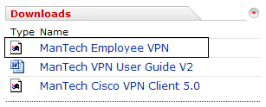

- Click on Connection Entries, then Import. Browse to the directory where you downloaded the ManTech Employee VPN.pcf file. Select the pcf file and click on Open. When you get the successfully imported message, click on OK.

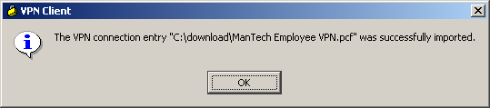

USING THE VPN CLIENT

- Select ManTech Employee VPN and click on Connect.

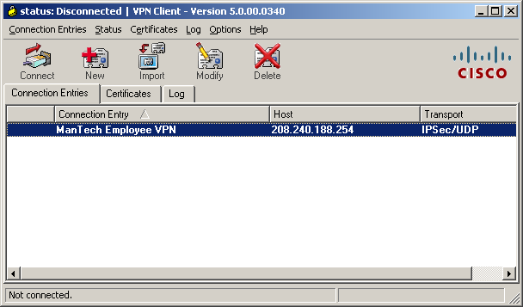

- Enter your ManTech Windows Network password(the password you use to access mantech.com Exchange Email, for example). You should not put mantech\ in front of your userid as you were previously required to do. Click OK.
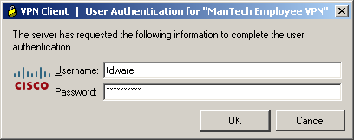

- Once the client successfully connects, you will see the system message. Please read the message and then click Continue to connect. You are now connected to the ManTech network.
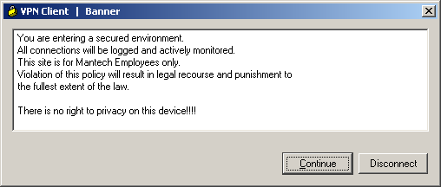

- A successful connection will also result in a small yellow padlock appearing in the Windows Task Bar System Tray, normally located in the lower right corner of your Desktop.

- When you are ready to disconnect from the ManTech Network, right click on the yellow padlock and select Disconnect. The yellow padlock will then change to an unlocked padlock.
