TASK: South African Military
ANALYSTS: Mark and Nate
INTERNS: Anya and Rami

Brief Background of South African Defense Force (SADF)

- The Defense budget for the period 1960-1974 reflects an increasing trend toward higher expenditures caused by the more resolute policy and higher costs associated with modern equipment like French fighter aircraft and rising inflation. Despite suggestions to the contrary, South Africa's defense posture remained defensive.

- Before 1963, South Africa depended heavily on arms imports. By the 1970’s South Africa military had become a modern force with advanced weaponry

- The SADF consisted of the army, the air force, the navy and the military health service. The SADF was organized along the lines of a conventional force and a territorial or counter-insurgency force.

- The SADF was a significant military power in Southern Africa and could field three army divisions supported by strong and sophisticated air and naval power.

- These forces relied heavily on part-time soldiers and conscripts (white male national service conscripts that served for an initial period of two years and then joined the part-time force for another ten years). The two-year obligation totaled, at its peak, 100,000 conscripts. This system allowed for the rapid expansion of the SADF if and when required.

SADF Doctrine:

- The strategic posture of the SADF was based on a pre-emptive, operationally offensive approach, and the force was also designed around this approach.

- The fundamental principle was that all threats had to be met outside South African territory by highly mobile forces with high firepower and strategic reach.

Historical Evolution of SADF
1948-1960

- South Africa's defense strategy and the composition of its forces prior to 1960 were largely determined by its relationship with Great Britain.

- Under the Union's agreement with Britain on the regional defense of Southern Africa much of the responsibility and force was to be supplied by Britain. Under the protection of Britain, there was little need for large expenditures on standing forces or sophisticated weapons.

- Consequently, much of the equipment of the armed forces was aging and obsolete. External military threats to South Africa were virtually non-existent in the early 1960s. None of the newly independent Black African nations had military forces of any consequence. Most of these new governments were highly dependent on their former colonial rulers.

- Adding to South Africa's secure defensive posture was its relative isolation from the rest of black Africa. Its immediate neighbors, Rhodesia, Swaziland, Mozambique, Botswana and Angola apparently constituted a secure buffer zone against external military intervention

- Between 1948 and 1960 the dominating Nationalist Party sought to place the Armed Forces under Afrikaner leadership as they had the police and civil service.

- Many British-trained, English-speaking officers with wartime experience were prematurely retired and replaced with Afrikaners of little or no combat experience. Such changes in the Air Force and Navy were less drastic because most of the technical personnel of both services were English descendants.

1960-1974

- Initially improvements in the Republic’s Defense Forces were directed toward helping the police maintain law and order and in the replacement of aging and obsolete equipment.

- Period of modernization and expansion of South Africa's Defense Forces triggered by internal threats (ex: events at Sharpeville in 1960), 1963 UN arms embargo, and creation of the Organization of African Unity, also in 1963.

- South Africa's defense posture remained defensive. Its ships had been primarily patrol vessels and not troop carrying or landing support ships.

- The aircraft acquired since 1960 had been for reconnaissance, close air to ground support and air defense fighters. In offensive roles they would have been severely limited in range and payload delivery. Until potential targets such as large concentrations of troops or supply bases come within range of these weapons systems, they would have very limited offensive value.

- The structure of South Africa's Defense forces emphasized defense against landward threats by concentration on highly mobile air and ground forces with only small investments in major warships or long range aircraft.

- By using such mobile air and ground forces attempts to infiltrate South Africa's frontiers, land or sea, with small groups of guerrilla fighters could have been handled by direct physical containment. If larger forces were used the use of interdiction and massive firepower would tend to force unacceptable losses on any aggressor.

Threat of AU:

- The creation of the Organization of African Unity (OAU) in 1963 presented a new external threat in the form of a potentially united group of black African states pledged to the abolition of white minority regimes in Africa.

White Paper of 1964:

The main threats identified were:

- An external attack from black states aided by the communists
- A major East versus West conflict with South Africa on the Western side
- The possibility of United Nations or combined international intervention and coercion on the pretext of enforcing international laws

White Paper of 1969

- It clearly set out a priority for the development of military defenses against guerrilla warfare as well as conventional attack.

- Previously, the counter-insurgency role had been assigned to the South African Police Force with the military used as a reserve.

Armament Purchases:

- Many of the armament purchases made since 1969 have been of the type designed to play an important ole in counter-guerrilla warfare; primarily helicopters and improved communication system.

- Training too has reflected a build up in defense capability for countering guerrilla penetrations.

1973:
- By the end of 1973, after more than a decade of repressing the African challenge within South Africa and building up its capability to deal with external threat South Africa's Defense and Foreign Policy objectives were:

  - To improve its relations with Western and pro-Western countries to prevent its total isolation in the world community

  - Protection of its frontiers by maintaining close relations with Rhodesia and the Portuguese in Mozambique and Angola, and by developing a good neighbor policy towards Lesotho, Swaziland, Botswana and Malawi while promoting "dialogue" with Africa

  - To continue attempts to gain some type of military alliance with the North Atlantic Treaty Organization or the United States to counter communist influence in the Indian Ocean, South Atlantic and Southern Africa

1974: SADF Structure and Capabilities

The South African Defense Force consists of four distinct parts:

    - Permanent Force
    - Citizen Force
    - The Commandos
    - The South African Police

1) The Permanent Force

- Consists of career officers and men of the Army, Navy and Air Force

- They serve a minimum of twenty years with a mandatory retirement age of 55 years: in 1974 there were 15,700 men as compared to 9,019 in 1960.

- In peace time role of the Permanent Force is to provide training to the 31,750 draftees serving on active duty with the various Army, Navy and Air Force units.

- These units can be employed to back up police forces in internal security problems and also perform patrol duties on South Africa's sea and land frontiers.

- In time of war, the Permanent Force would make up the leadership cadre of the mobilized reserve Army, Navy and Air Force Units.

1974 Army

- The Army is South Africa's largest service. At the end of 1974, total strength of active duty was approximately 7,000 regulars and 22,500 draftees.

- The standing force was organized into three brigades: tank, infantry and artillery. With the full mobilization of the 60,000 man citizen force, the Army would consist of over 50 major units including at least 40 infantry battalions; some of which are designated as Mobile Watches equipped with tanks, rocket launchers, and anti-tank weapons.

- Other units designated as Joint Combat Forces, make up an elite strike force claimed to have the capability of providing a 500 man taskforce completely equipped for airlifting to any spot in the country within 90 minutes.

- Beginning in 1969, the South African Defense Force began training all of its Army combat units in unconventional warfare and anti-guerilla tactics.

- Although a small number of Army units have engaged in antiguerrilla operations in the Caprivi Strip, overall combat experience in the Army is limited to a few senior members who saw action in World War II.

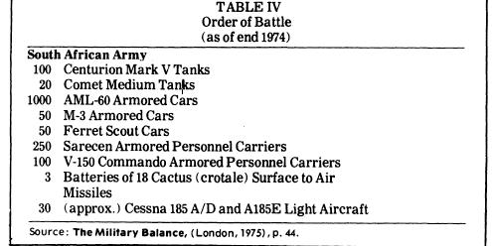
1974 Air Force

- The Republic's Air Force is considered the strongest and best equipped in Sub-Saharan Africa

- At the end of 1974 there were 5, 500 regulars and 3,000 draftees on active duty and several hundred aircraft. Air Force Reserves constituted 3, 000 men of the Citizen Force and several hundred aircraft including 12 squadrons of Air Commandos and private aircraft.

- The Air Force is composed of five main operational units:
  - The Strike Command had two squadrons of jet fighter bombers
  - One squadron of jet reconnaissance-bombers
  - Three armed helicopter squadrons.

- The Maritime Command consisted of one squadron of conventional patrol planes and a flight of anti-submarine warfare helicopters. Three squadrons of light and heavy transports comprise the Air Transport Command. Air Force personnel also operate the Republic's Air Defense system and the radar sites of the early warning network.

- The Air Force is equipped with first line tactical weapons systems including French Mirage III jets, air-to-air and air-to-surface missiles. Fifty Mirage F -l's have been purchased and are programmed for assembly in South Africa beginning in 1975.

- Initial flying training is given in single engine Harvard trainers followed by basic jet instruction in Italian Aermacchis assembled in South Africa under the designation" Impala."

- Several major Air Force bases are located throughout South Africa and one in Southwest Africa (Namibia).

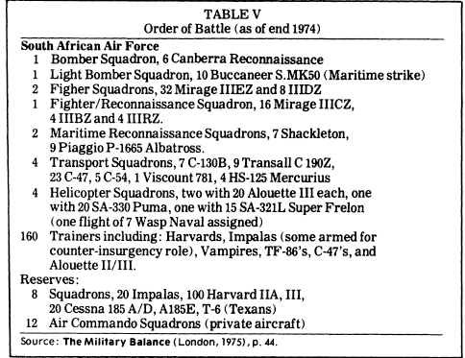

1974 Navy

- At the end of 1974 the South African Navy had 3,200 regulars and 1,250 draftees on active duty. There were 9,000 trained reserves in the Citizen Force.

- Twenty-eight line ships, not counting the support and auxiliary vessels, are used to patrol and safeguard the Republic's extensive sea approaches.

- Since British withdrawal of its military forces from the Indian Ocean in 1971, the responsibility of protecting western sea lanes near and around the Cape of Good Hope has been assumed by the South African Navy.

- For purposes of strengthening her own position and obtaining new equipment, South Africa has sought to conclude alliances with NATO and individual western countries in order to fill the vacuum created by the British departure and to augment her limited Navy in its patrol duties. South Africa has begun enlarging her naval facilities at Simonstown in anticipation of future allies and to accommodate her own expanding Navy.

- The Headquarters of the South African Navy is located at Simonstown naval base across the Cape Peninsula from Cape Town. South Africa also has a naval base near Durban and one at Walvis Bay on the coast of Namibia (South West Africa).

- A multi-million dollar underground communications complex at Silvermine is used to charts hip movements in an operational area ranging from Antarctica to North Africa and from South America to Bangladesh. Information on Soviet naval units in the area is furnished by this facility to the United States and Great Britain.

- Plans to expand the Navy to approximately forty-five line ships are hindered by South Africa’s limited naval construction capacity and the difficulty of finding suppliers.

- Modernization and expansion have been concentrated on anti-submarine warfare and coastal patrol to prevent infiltration from the sea.

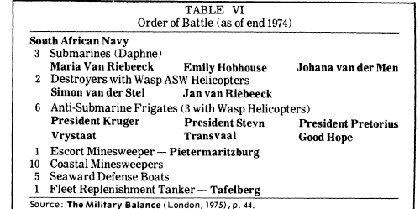

2) The Citizen Force

- Is organized into Army, Navy and Air Force nits in 9 territorial commands. Reserve strength has risen from 2,000 in 1961 to 72,000 by the end of 1974.

- It is estimated that the total Citizen Force could be mobilized within two days. 31,750 draftees destined for the Reserves were serving on active duty with the Permanent Force during 1974.

3) The Commando unit

- Is essentially a paramilitary force of volunteers organized into infantry and air components and serving as a Home Guard.

- In 1974 they numbered some 75,000, up from 48,281 in 1960

4) The South African Police (SAP)

- Is a national centrally-controlled law enforcement agency of more than 34,000 regular policemen and 19,000 police reservists.

- It is the primary instrument for enforcing law and order and preserving internal security within the Republic. In accomplishing its mission of insuring internal security, the South African Police has concentrated on improving and developing a capability for detecting subversive conspiracies against the government. In this respect it has earned both a national and an international reputation for its success in eliminating subversive threats.

- In 1965 a number of mobile police units specially trained in guerrilla warfare, were established in strategic areas and were available for assignment on short notice to quell riots, strikes or guerrilla infiltrations.

By the end of 1974:

- South Africa appears to be well equipped to meet any military threats from neighboring African States either guerrilla or conventional.

- Her sophisticated weapons, developed communications and strong economic base far outweigh the capabilities of any of the other African States South of the Sahara.

1975-1989

- The trend towards militarization continued

1989-1994

- A major reorganization of the South African Defence Force got under way following the disengagement from Angola and the withdrawal from Namibia, and to meet President F.W. de Klerk's policy priority of attempting to solve the country's economic problems.

- Among the measures being taken to streamline the Force is the retirement of the most elderly equipments, which require an excessive degree of maintenance. The Air Force, for example, retired its Canberra bombers and SA-321 helicopters.

- The Navy abandoned its deep-sea capability to concentrate on in-shore operations. The number of bases was reduced and the Marine was disbanded and its reserve manpower transferred to the Army as infantry.

Post-Apartheid: South African National Defense Force (SANDF)

Brief Overview:

- South Africa maintains an all volunteer set of armed forces, which represents the best-equipped and most advanced military on the African continent.

- South Africa has the largest defense budget in Southern Africa.

- SANDF continues its strategic shift from a territorial defense force to an interventionist, rapid reaction force, force levels should continue to decline.

1998 White Paper

- White Paper policy direction, the Defiance Review (1998) describes the national strategy for the defense and protection of the state and its people through the hierarchy of:

- Political, economic and military co-operation with other states
- The prevention, management and resolution of conflict through nonviolent means
- The use or threat of force as a measure of last resort.

- The overemphasis on the primary function of the SANDF as the defense of South Africa against external military aggression. The hierarchy for the defense of South Africa:

- Prevention of conflict and war
- Containment of conflict and war
- Employment of military force as the last option

‘Army Vision 2020’

- ‘Army Vision 2020’ project deals with the refocusing and reorganizing of the South African Army outlining its most likely operational environment for the medium term and how it intends to meet those demands

- Based on the government’s policy of engaging with Africa, Vision 2020 calls for:

- An increased expeditionary capability to participate in peace support operations and protect national interests outside of the state

- A response to the growing complexity of war and complex human factors

- A readiness of joint operations with other states, or between agencies

- To meet these demands the army is likely to undergo a number of structural changes including the establishment of a number of divisions and brigades to:

- Form the core conventional combat capability – a Mechanized Division

- Provide force in peace support operations – a Motorized Division

- Provide airborne and sea-landed capabilities for rapid deployment operations – a Special Operations Brigade

- Carry out construction under developmental peacekeeping missions – a Works Regiment

- Defense minister Mosioua Lekota lay out five defense priorities for financial year 2007/08:

- The renovation of SANDF facilities that fell into disrepair as a result of poor funding. A construction regiment is to be formed to carry out such work and help with developmental peacekeeping

- The Reserve Force is to be revitalized to provide support for peace support missions and to the police, if necessary

- The implementation of an ‘integrated financial management system’

- The modernization of the army to counter increasing problems with old equipment

- The ‘operationalisation’ of the much-delayed Defense Update to set out a force design that is better aligned to the realities of the current SANDF deployments.

2009 External Security Situation

- The current government expresses South Africa’s national interests in traditional ‘liberal interventionist’ language. Thus, the country seeks to ‘export security’ across the continent, in order to create the preconditions for economic growth.

- It is the promotion of such development models that will form the ultimate guarantor of South African security. In this regard, the country has taken a lead role in establishing formal military ties across the region.

- The SADC is in the process of adopting a ‘Joint Defense Pact’, which, although not as binding as a North Atlantic Treaty Organization (NATO)-style agreement, would nevertheless facilitate South African involvement in the inter- and intra-state conflicts of its neighbors.

- Roughly 1,700 troops have been deployed internally in support of the police force, primarily along the country’s long land borders, in order to meet the threat from immigration and trafficking. In response to funding difficulties, this support role looks likely to be reduced significantly over the next few years, as external deployments increase.

Overseas Deployments

- The SANDF is today extensively deployed in peace support operations in Africa and is coping well with this new challenge. This is an important development because these deployments will greatly enhance the skills basis of the new defense establishment through the exigencies of such operations

- A greater role for SANDF in regional intervention and peacekeeping is envisaged, requiring a slimmed-down, highly mobile and flexible force

- In support of South African, AU and international efforts at conflict prevention and management, the SANDF has become increasingly engaged in peace support operations on the continent

- These operations will serve as a testing ground, but also as a learning experience for the new SANDF in the fields of operational planning, intelligence, logistic support and management of deployed personnel

- South African forces are deployed to a number of foreign countries, largely on peace support missions. The military’s ongoing activities conform to an expeditionary vision.

- The SANDF is, however, not well equipped for these types of operations as its force design is predicated on short logistic lines for highly mechanized mobile forces prepared to fight in defense of the territorial integrity of the country and not for out of-area force projection and support in distant places

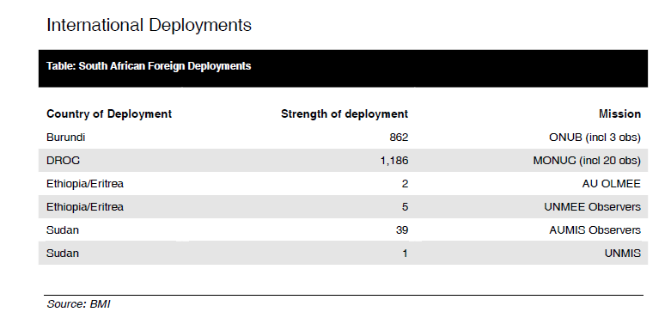

- There is a worrying mismatch between defense funding and defense commitments, aggravated by South Africa’s expanding regional security role. These are impacting on the capability of the South African army.

- On January 25 2007, South African Defense Minister Mosiuoa Lekota declined to provide any South African forces for the AU’s mission in Somalia because its forces were considered to be already overstretched.

2009 South Africa Security
Strengths

- Regional hegemony is supported by Africa’s most advanced military and the continent’s highest military expenditure

- Increasingly strong alliances with Western countries are balanced by a robust African identity following the end of apartheid

- South Africa’s strategic position on the cape makes any naval invasion difficult, while its geographic isolation from Europe and North America protects it from indirect missile threats

Weaknesses

- South Africa’s position amid an unstable southern Africa leads to relatively high levels of trafficking across its extensive borders

- Ethnic divides and a two-tier economy have increased incidences of crime

- Lengthy borders and desert terrain make effective policing difficult

Opportunities

- Greater power projection is leading to South Africa becoming a ‘security exporter’ with the aim of helping to stabilize security situations on the African Continent

- The Black Economic Empowerment (BEE) program is slowly improving the lot of the black population and decreasing economic divisions along racial lines

- The government’s growing awareness of the problem of HIV could lead to much needed positive policies in the future

Threats

- Instability in neighboring Zimbabwe could spill over into South Africa and cause significant numbers of displaced persons or even internal civil unrest

- The significant level of HIV/AIDS in South Africa poses a threat to civil society, with government policy discounting the problem until recently

- A rising prevalence of piracy globally, and within Africa’s waters, endangers South Africa’s key shipping lanes and maritime trade

- Alliances with the US and other key allies make South Africa a viable terrorist target, although no threats have yet arisen

2009 Internal Security Situation

Organized Crime

- South Africa experiences a great deal of movement of people, drugs and weapons across its long northern border. This has contributed to the country’s severe socio-economic problems, particularly in the cities.

- A study conducted by Safety Assessment Principles (SAPS) found that in 2003-2004 there were 341 active syndicates, with at least 98 known to be involved in drug trafficking. Most of those syndicates are foreign, primarily Nigerian. Chinese Triad, Pakistani, Russian, Indian, Tanzanian, Venezuelan and Colombian syndicates are also present and active in the trade in illicit drugs.

- South Africa has one of the highest global levels of domestic gun-related deaths, with over 30 people killed daily.

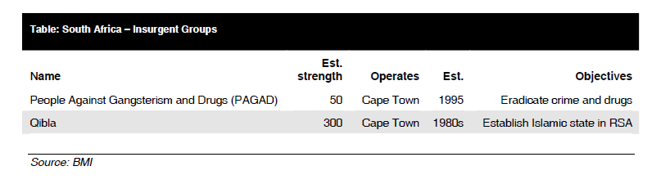

- The major internal security development in South Africa in 2008 was the outbreak of very serious antiimmigrant riots in a number of areas of the country. This situation stabilized in June with South Africa Troops being withdrawn from Johannesburg and Cape Town townships.

- In June 2008, a 15-member team from the UN Counter-Terrorism Executive Directorate (CTED) was visited South Africa to assess its security legislation, enforcement capacities, and anti-terror measures. The visit was part of the CTED’s routine program under UN Security Council (UNSC) resolutions. George Nene, a South African foreign ministry official, was quoted by news agencies noting that the country had ratified all 13 UN-supported universal conventions on terrorism, and supported a multilateral approach to the issue.

Sources

2009 Military Balance, South Africa

South Africa Defense & Security Report Q2 2009

South Africa Defense & Security Report Q3 2008, Military Structure And Defense Industry

South Africa Defense & Security Report Q4 2008

South Africa Defense & Security Report Q4 2009

Department of Defense FY 2006- 2007 Annual Report

Chapter Nine: The post-apartheid South African military: Transforming with the nation, Evolutions & Revolutions

Michael Schieber, Apartheid Under Pressure in Africa Today, v.23, no.1, 1976

Neta Crawford, South Africa’s New Foreign and Military Policy in Africa Today, v. 42, no.1/2, 1994

GRIPEN:
http://www.defenceweb.co.za/index.php?option=com_content&task=view&id=4983&Itemid=350

.

