HEALTH AND MEDICATION ADMINISTRATION MANUAL
FOR PERSONS WITH INTELLECTUAL/DEVELOPMENTAL DISABILITIES

A STUDY GUIDE AND REFERENCE MANUAL
Section 1 2024

ACKNOWLEDGEMENTS
In 1977, the Montana State Legislature passed an amendment allowing non-medical professionals to assist and supervise in the self-administration of medications by persons with intellectual/developmental disabilities (53-20-204 MCA). For non-licensed staff to assist with medications, the medication must usually be self-administered and must be prescribed by an authorized provider with license to prescribe medications such as a physician, psychiatrist, nurse practitioner, or physician assistant.
This is the latest version of the “Health and Medication Administration Manual” which is to be used as a study guide so that non-licensed staff can become certified to assist with medications pursuant to the Administrative Rules of Montana.
This manual was written by Jean Justad, MD, Medical Director for Developmental Disability Services.
Previous manuals:
2009, Health and Medication Administration Manual, Jean Justad, MD,
illustrated by Mike Petersen, QIS
1998, Managing Medications in Developmental Disabilities Program-Funded Services, William J. Docktor, Pharm. D. with Perry Jones
1988, Seizure Disorder and Medications, William J. Docktor, Pharm. D. with Michael Jacupcak, Ed. D., and Dana McMurray
1980, Epilepsies & Medications, Chrys Anderson, Melinda Artz, and Patti Bates
Many people have been involved in the development of these medication manuals. There is not enough space to give credit to everyone. The current manual is a sum of past contributors and new research. A special “thank you” is given to all.

Table of Contents
Chapter 1. INTRODUCTION 1
A. PURPOSE of manual 1
B. Goals 1
C. MEDICATION CERTIFICATION 1
Chapter 2. THE ROLE OF THE CAREGIVER 4
A. Your role as a caregiver 4
Chapter 3. GENERAL INFORMATION 7
A. GENERIC VS. BRAND NAMES 7
B. OVER THE COUNTER VS. PRESCRIPTION 7
C. PRN MEDICATIONS 8
D. PRN PROTOCOLS 8
E. CONTROLLED SUBSTANCES 9
F. STORAGE OF MEDICATIONS 9
1. Temperature: 9
2. Moisture: 9
3. Light: 9
4. Air: 9
5. Time: 9
G. DISPOSAL OF MEDICATIONS 10
H. CUTTING AND CRUSHING MEDICATIONS 11
I. mixing medications with food 12
J. Taking medications on an empty stomach 12
K. monitoring medications 13
L. New prescriptions 13
Chapter 4. FORMS OF MEDICATIONS 14
A. ORAL MEDICATIONS 14
1. Tablets and capsules: 14
2. Sublingual medications: 14
3. Buccal medications: 14
4. Liquid forms of medications: 14
5. Techniques for measuring liquid medications: 15
B. medications absorbed through skin/membranes 15
1. Transdermal medications: 15
2. Lotions, creams, ointments, and drops 15
3. Vaginal and rectal medications 15
C. inhaled medications 16
1. Metered dose inhaler (MDI): 16
2. Dry powder inhaler (DPI): 16
3. Nebulizer: 16
D. Supplemental oxygen (o2) 16
Chapter 5. ADMINISTRATION OF MEDICATIONS 18
A. Before administering medications 18
B. standard precautions 18
C. preventing transmission of infections 18
D. the rights of medication administration 20
1. The right PERSON: 21
2. The right MEDICATION: 21
3. The right DOSE: 21
4. The right TIME and DATE: 22
5. The right ROUTE: 22
6. The right POSITION: 23
7. The right FORM: 23
E. preparation Before giving medications 24
F. giving or applying medication 24
G. steps for medication administration 25
Chapter 6. DOCUMENTATION 26
A. The abc’s of charting 26
B. the Medication Administration Record (MAR) 26
C. Transcribing 26
D. charting rules for use of a paper Mar 26
Chapter 7. FILLING OUT THE MAR 28
A. GENERAL RULES 28
B. why learn how to fill out a paper MAR? 28
C. Abbreviations 30
D. dosing schedules 31
E. step-by-step: filling out the mar 32
Chapter 8. MEDICATION ERRORS 38
A. types of medication errors 38
B. why do medication errors occur? 38
C. When a Medication is TAKEN BY the wrong person 39
D. Missed medications 40
E. reasons medications are not given or taken 41
F. transcription errors 41
Chapter 9. TYPES/CATEGORIES OF MEDICATIONS 44
A. EYE (OPHTHALMIC) MEDICATIONS 44
B. ear (otic) medications 44
C. nose (nasal) medications 45
D. TOPICAL medications 45
E. inhaled medications 46
F. ANALGESICS 46
1. Nonsteroidal anti-inflammatory drugs (NSAIDs): 46
2. Acetaminophen (Tylenol®): 46
3. Tramadol (Ultram®): 47
4. Opioids (narcotics): 47
Chapter 10. MEDICATIONS FOR PSYCHIATRIC CONDITIONS 48
A. ANTIDEPRESSANTS: Serotonin Syndrome 48
B. antipsychotic agents 49
C. anxiolytics and hypnotics 54
Chapter 11. SEIZURE DISORDERS 56
A. seizures 56
B. CAUSES OF SEIZURES OR EPILEPSY 57
C. influencing factors 57
D. TYPES OF SEIZURES 59
E. first aid for seizures 63
F. documentation 65
G. treatment 65
H. status epilepticus 68
Chapter 12. STROKES AND TIAs 69
A. TIA (TRANSIENT ISCHEMIC ATTACK) 69
B. stroke 69
C. Risk factors for stroke and tia 70

Chapter 1. INTRODUCTION

PURPOSE of manual
- To teach how to assist clients take their medications correctly.
- To teach how to correctly read and fill out a medication administration record.
- To teach, in general, how medications work, some common side effects, and other important issues with them.
- To teach important aspects about caring for someone with intellectual/developmental disabilities (IDD).
- To teach how to recognize problems, including adverse reactions from medications, when caring for someone.
- NOTE: For continuity in this manual, staff providing direct services to persons with intellectual/developmental disabilities shall be referred to as direct support professionals (DSPs) or caregivers. The people that DSPs care for shall be referred to as clients.

Goals
- Promote health, safety, and personal growth of persons with IDD.
- To become medication certified in order to assist with medications.

MEDICATION CERTIFICATION
- To become medication certified, you must be able to study and understand the information provided in this manual.
- You must then pass a written, open book, test.
- You will be tested on information contained in chapters 1 through 22, but not on information in the Appendices.
- You are encouraged to read the information in the appendices as they provide more comprehensive information.
- Medication certification expires after two years. You will be expected to recertify by taking the test before certification expires.
While taking the test, you will not be given any assistance
with reading or understanding the material on the test.

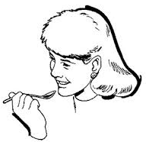


Medication certification allows you to:
- Assist with and administer topical, oral, and inhaled medications.
- Inject epinephrine (EpiPen®) or glucagon in an emergency situation but injecting insulin in any situation is not allowed.
- Determine if a PRN medication is needed by following protocols.
- Perform blood glucose monitoring.
- Administer oxygen.
Your certification does not allow you to:
- Discontinue a medication without an order from a medical provider.
- Give any medication (even an over-the-counter medication) without an order from a medical provider.
- This includes the use of any type of topical OTC treatment.
- Change the frequency or dose of a medication without an order from a medical provider.
- Take phone orders from a medical provider. However, advice can be taken from health care providers, nurses, and pharmacists.
- Share health related information with anyone who is not a member of that person’s care team.
- Represent yourself as a licensed healthcare provider.
- NOTE: a medical provider is someone with a license to prescribe medications.
Even with a Medication Certificate, you may not:
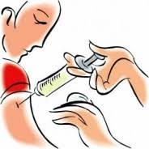

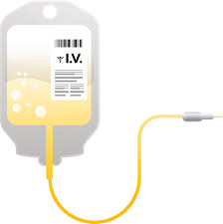
- Administer anything through a nasogastric (NG) tube, nasointestinal (NI) tube, or J-tube.
- Give anything through an intravenous
(IV) line.
- Give an intramuscular injection.
- Perform deep suctioning.
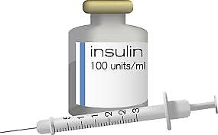
- Inject insulin, calculate insulin
dosages, or manage an insulin
pump in any way.

TO SAFELY ASSIST WITH MEDICATIONS
AND TO TAKE AND PASS THE REQUIRED TEST,
YOU MUST:


- BE ABLE TO READ AND UNDERSTAND WRITTEN MATERIAL IN ENGLISH WITHOUT ANY ASSISTANCE OR SPECIAL ACCOMMODATIONS.

- BE ABLE TO WRITE LEGIBLY AND FILL OUT DETAILS ON MEDICATION ADMINISTRATION RECORDS.
- BE ABLE TO PERFORM THESE TASKS IN A NOISY, DISTRACTING ENVIRONMENT.

See Appendix 1. DEFINITIONS

See Appendix 23. SAMPLE TEST

See Appendix 24. ANSWERS TO SAMPLE TEST

Chapter 2. THE ROLE OF THE CAREGIVER

Your role as a caregiver

Teach/train clients to take medications independently when possible.

Assure that the proper medication is taken as prescribed.

Attain knowledge about the safe administration of medications:
- When used carelessly, drugs can be toxic, producing mental and/or physical distress or even death.
- Drugs can have unwanted effects which are known as side effects or adverse reactions.
- You should have some knowledge about how the drug works.
- You should have some knowledge of toxicity (damaging effect) of the drug.

Assist the medical provider (prescriber) by:
- Providing information about the client especially if the client is unable to provide information him/herself.
- Provide information about allergies.
- Provide information about concerns such as constipation and swallowing problems.
- Provide information as to problems with the client when it comes to administration of medication such as eye drops, ear drops, etc.

Know when to seek assistance for medical issues.
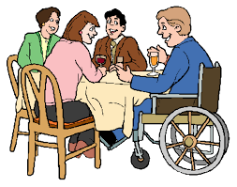
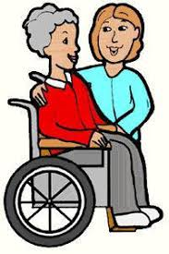
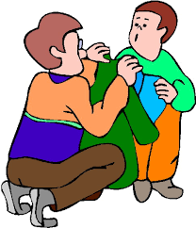

WHEN TO SEEK ASSISTANCE
If the situation warrants 911, CALL 911 FIRST,
then notify others per policy

Examples of when to call for an ambulance or call 911
► Poisoning

► Chest pain
► Cardiac arrest (loss of heartbeat)
► Difficulty breathing, severe wheezing or stops breathing
► Sudden loss of vision
► Choking if having difficulty breathing afterwards
► Severe or large areas of burned skin
► Uncontrolled or heavy bleeding or bloody vomit or stools
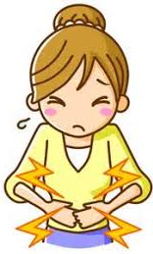
► Severe, constant abdominal pain
► Fainting, loss of consciousness, won’t wake up
► Appears very ill, sweating, skin looks blue or gray
► Possible stroke, new weakness, loss or change in speech
► Sudden development of unusual symptoms or behavior
► Low blood sugar that is not responding to usual interventions
► First time seizure; seizure lasting longer than usual
► Doesn’t wake up or takes more than a minute to breath after a seizure
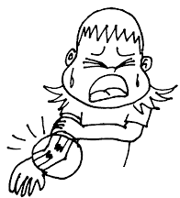
► Foreign object stuck into the body
► Fracture of an arm or leg
► Crushing injury of head, chest, or abdomen
► Hard blow to head or head injury from falling; fall on face
with bleeding, or change in level of consciousness after
fall or being struck
► Limb deformity after a fall (bone sticking out, unusual position of a limb)
► Unable to get up or in a lot of pain after a fall
► Severe allergic reaction with massive hives, difficulty breathing, swelling
of throat, tongue, lips, or mouth
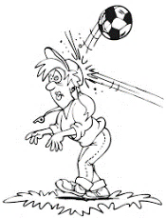
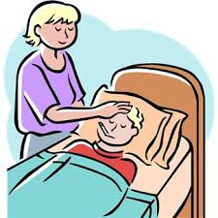
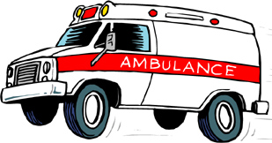

Examples of When to Take an Individual to the ER/Hospital/Urgent Care

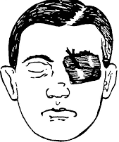
► Eye injury.
► Burn that blisters (including severe sunburn).
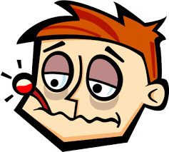
► Shaking chills with or without a fever.
► Temperature of 103 degrees F or higher.
► Repeated vomiting/diarrhea over 12 hours.
► New onset of confusion for no known reason.
► Complaining of pain or not walking normally after a fall.
► 24 hours of poor eating/drinking with a dry mouth and tongue.
► Moderate bleeding that stops after 5 minutes of direct pressure but may need sutures. Apply pressure while transporting.
Examples of When NOT TO MOVE an Individual

► Fall with limb deformity noted such as a bone sticking out, swelling,
unusual position of arm or leg.
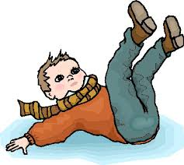
► Fall with severe head injury such as fall onto face, with bleeding, or change in level of consciousness.
► Fall, unable to get up, and having a lot of pain with either lying still or when trying to move.

Examples of When to Contact the Medical Provider
► New rash.

► Fever of 101 to 102.9 degrees F.
► Earache or sore throat.
► New onset of incontinence or complaints of discomfort with urination.
► Increase in seizure numbers, type, or duration.
► First degree burns, including sunburns
(that are reddened or blistered).
► Repeated vomiting/diarrhea for more than 6 but less
than 12 hours; not holding down small sips of liquids.

See Appendix 2. THE ROLE OF THE CAREGIVER for more information.

Chapter 3. GENERAL INFORMATION

GENERIC VS. BRAND NAMES
Medications are referred to by two names: generic and brand (trade) name.

Generic name, can be used by any manufacturer:
- Identifies the active ingredient in the drug product.
- Are not capitalized within a sentence.
- Generic products generally cost less but are as effective.
- The pharmacist may substitute a generic product for a brand name unless otherwise written as “do not substitute” on the prescription.

Brand name (trade name):
- Is the name of a distinctive product (medication) that a company produces and registers.
- Distinguishes that product (medication) from others.
- Is capitalized and identified with the registered trademark symbol ®.

Examples:
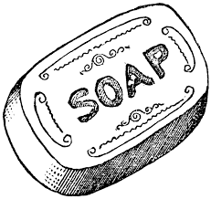

- Soap (generic) – Dove® (brand name for a specific soap product).

- Acetaminophen (generic) – Tylenol® (brand name for a specific product containing acetaminophen).
- Lorazepam (generic benzodiazepine) – Ativan® (brand name for specific product containing lorazepam).


OVER THE COUNTER VS. PRESCRIPTION

Over the counter (OTC) drugs:
- Nonprescription drugs - may be purchased without a prescription.

Prescription drugs:
- May only be obtained with a prescription.


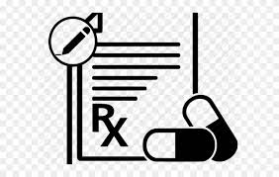
You, as a caregiver or DSP, may ONLY administer a medication if there is an
ORDER from a medical provider
regardless of whether the medication is
classified as OTC or prescription.

PRN MEDICATIONS

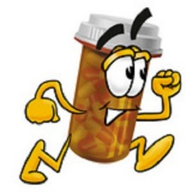
PRN is an abbreviation for the Latin pro re nata meaning “when needed” or as more commonly stated, “as needed”.

It is used when a medication is only given under certain circumstances, not on a scheduled basis.

A PRN eliminates delays when taking a needed medication.

PRN OTC medications must have an order from a prescriber before use unless the person is totally independent in taking medications and able to purchase OTC medications for his/her personal use.

PRN PROTOCOLS
EVERY PRN MEDICATION THAT REQUIRES STAFF
ASSISTANCE MUST HAVE A WRITTEN PROTOCOL.

PRN medication protocols (whether for OTC or prescribed medications) must contain:

Name of the person receiving the medication.

Name of the PRN medication.

The exact dose that is to be given.

How often the medication can be given.

The conditions or symptoms for which the medication can be given.

The route by which the medication is given (oral, topical, rectal, etc.).

The length of time or time frame for giving a medication before staff must respond in a different way such as notifying the medical provider or a nurse, etc.

Documentation must occur on the Medication Administration Record.

PRN psychotropic/psychiatric medication protocols:

PRN psychotropic and other medications used for behavior, or a psychiatric reason may never be used for the convenience of staff but must have clear and objective guidelines for use.

PRN psychiatric medications are never to be used in place of behavioral support strategies.

PRN psychiatric medications are never to be used as punishment.

PRN psychiatric medications are never to be used as a chemical restraint.
See Appendix 3 for more information on protocols

CONTROLLED SUBSTANCES
Schedule II drugs (pain relievers such as hydrocodone) and amphetamines (Ritalin®, etc.) are handled differently from other medications.
- When present in a group home, Schedule II drugs:

- Must be stored in a locked cabinet or other secure area.
- Must have documentation tracking each dose.
- Must have “med counts” at shift exchange with documentation on a narcotic or controlled substances count
OPIOIDS
sheet to account for all medications.
- For supported living situations, it is strongly suggested that med counts be done at a minimum of once daily or at med passes.

STORAGE OF MEDICATIONS
Medications can break down if not stored properly. To maintain potency (strength) of medications the following conditions must be taken into consideration:


Temperature:
- Too warm or too cold makes medications lose effectiveness.
- Room temperature is best unless there are instructions to store in the refrigerator.
- Avoid freezing unless special instructions are given for this.


Moisture:
- Store in a dry place.
- Avoid moist, damp places such as bathrooms, near dishwashers, near the stove, etc.


Light:
- Can deactivate some medications.
- Containers are usually opaque to guard against this.

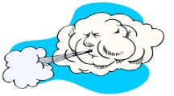
Air:
- Air or oxygen can inactivate some medications.
- Keep containers tightly closed to limit exposure to air.

Time:

- Over time medications will break down, thus they have an expiration date.
- Make sure that expiration dates are noted, and new medications are obtained before the ones in use expire.

DISPOSAL OF MEDICATIONS
- Medications that are expired, contaminated, refused, or discontinued must be disposed of safely.
- A medication should never be kept in case it is restarted.
- One person’s medications cannot be used by another client.

To dispose of medications:

Check the prescription label to see if there are directions for disposal.

Check if there is an authorized collection site in the community such as at the hospital or pharmacy.

Check the FDA flush list to see if it can be flushed down the toilet.

US Food and Drug Administration Guidelines for disposal of drugs:
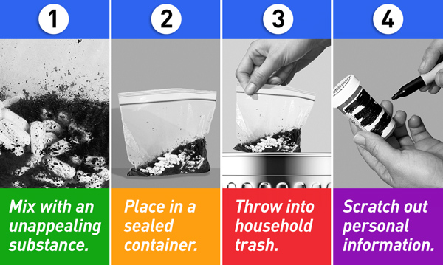

fda.gov/consumers/consumer-updates/where-and-how-dispose-unused-medicines

Mix medications with something such as coffee grounds or kitty litter before placing in a sealed container and discarding into trash.

Make sure personal information is removed from pill bottles, etc.

Record the name and amount of medication destroyed and the method used on a medication disposal form.

Never flush drugs down the toilet unless listed on the FDA flush list.

Controlled drugs must be counted before disposal and witnessed by two people.

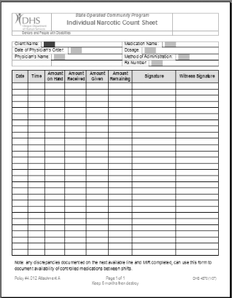

Oregon Department of Human Services

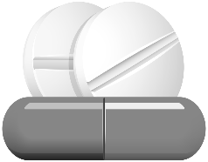
CUTTING AND CRUSHING MEDICATIONS
Many people have difficulty swallowing whole tablets or capsules or need a dosage that is less than a whole tablet in size. Cutting or crushing tablets and emptying capsules is acceptable for many medications.

General Rules:

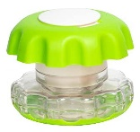
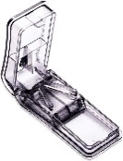
Scored tablets, which have an indented line across them, are easily broken.

Tablets can be cut with a pill splitter.

Tablets may be crushed with:
- Pill crusher
- Mortar and pestle Amazon.com Walmart.com

Never place pills inside a plastic bag and bludgeon with a heavy object because:
- It can make holes in the bag and some medication can be lost.
- The crushed medication can collect in the corner of the bag, making it difficult to get it all out.
- It may result in chunky pill fragments, rather than smooth powder.

Medications that cannot be cut, crushed, or opened include:
- Extended release
- Sustained release
- Sustained action
- Slow release
- Time release
- Repeat action
- Delayed release
- Enteric coated

Clarify that it is acceptable to cut or crush a medication or open a capsule by calling the pharmacy.

If a client has difficulty swallowing a medication, ask the pharmacist or medical provider if a liquid or other form of the medication is available.

Each medication should be crushed and then taken separately.


mixing medications with food

Medications can often be mixed with food to ease swallowing:

- Tablets may be crushed and mixed with food.

- The contents of a capsule may be emptied into food.
- Whole tablets may be easier to swallow if taken with a spoonful of food.


Foods to use:
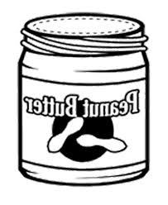
- Applesauce, pureed fruit, baby food, custard, pudding, ice cream, yogurt, mashed bananas, cottage cheese, or other soft, mashed foods
are appropriate.
- NEVER use peanut butter or honey.
- Both peanut butter and honey are hard to handle in the mouth and are associated with a HIGH CHOKING RISK.

General rules:

Mix medication with a small amount of food so it can be taken at once.

After the entire amount of medication is swallowed, follow with a glass of liquid to help the medication get into the stomach and be absorbed.

Do not place a container of food mixed with medication in the refrigerator or leave on the counter.

The entire amount of food containing the medication must be finished at the time it is given because:
- a container may accidentally be consumed by another client.
- if the client fails to take the rest of the food mixed with medication later as planned, he will then miss part of that dose.

Never mix liquid medications together.

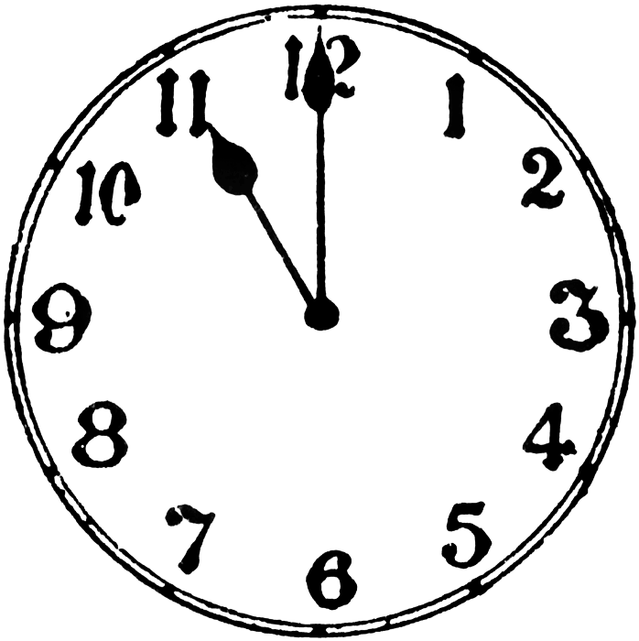
Taking medications on an empty stomach

Also known as NPO (nothing per “os” or mouth)

Food and beverages in the stomach may interfere with absorption or slow the time it takes for a medication to

begin to work.

When giving a medication that is supposed to be taken NPO, give the medication 1 hour before or 2 hours after, eating or drinking.

monitoring medications

Monitoring is done by:
- Observing for symptoms or side effects.
- Measuring levels of the drug in the blood or other blood tests such as liver tests, blood sugar levels, etc.

Side effects:
- All medications have side effects that can be physical or emotional.
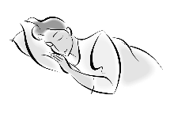
- Usually side effects are unwanted, but some drugs are prescribed to utilize potential side effects such as giving an antihistamine that causes drowsiness to help someone sleep at night.
- Side effects can be mild (nuisance) side effects, or they can be serious or even life threatening.
- Your job is to report any side effect observed.

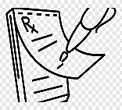
New prescriptions

At medical provider appointments, be sure to supply a list of all medications, including OTC and supplements.

The medical provider relies on you to report observations and concerns especially if a client is unable to relay that information.

If a new medication is prescribed, obtain a copy of the prescription, or at least have the provider write down the name of the drug and dose for you.

Information you should know regarding any new medication:

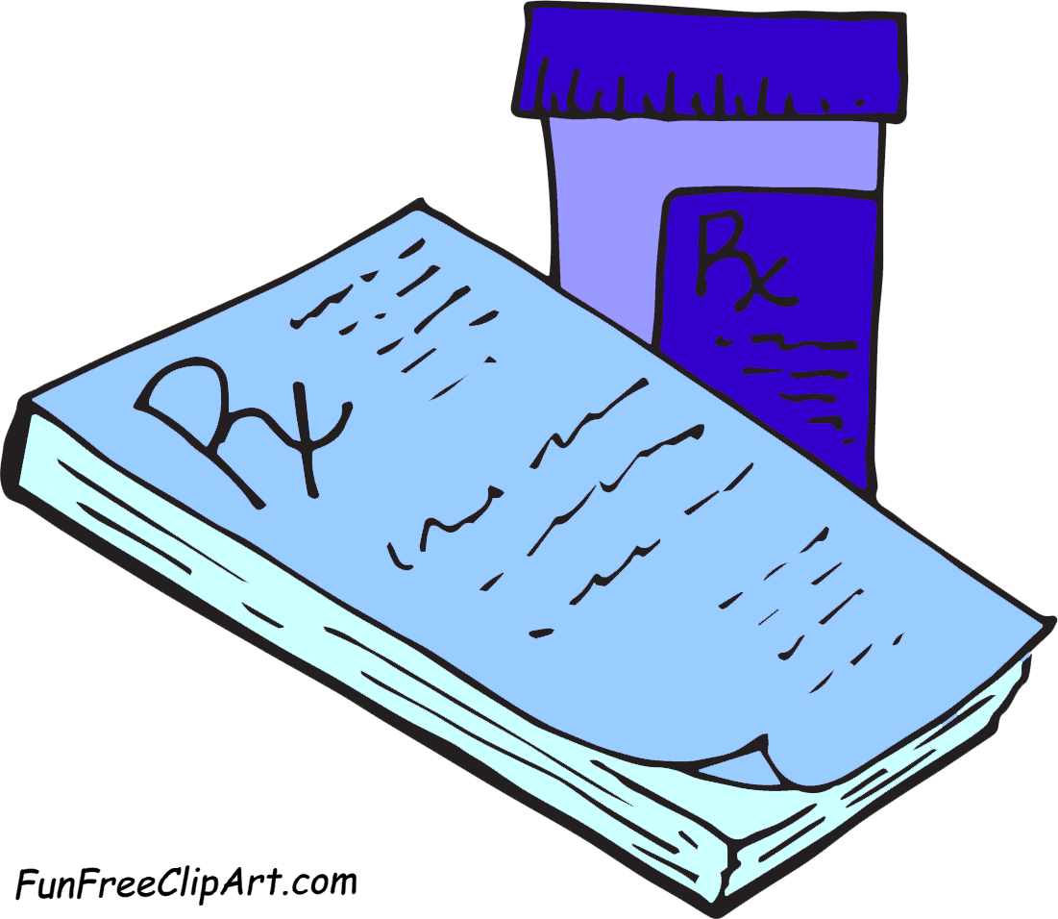
What is the purpose of the medication?

What signs or symptoms should the medication affect?

How long before changes should be seen?

How much medication should be taken; how often?

Can the medication be taken with meals or food?

How long should it be taken? Is it to be refilled?

What are some possible side effects? How should you respond to observed side effects?

Are any blood tests needed for monitoring?

When should a follow up appointment be scheduled?

See Appendix 3. GENERAL INFORMATION for more information.

Chapter 4. FORMS OF MEDICATIONS

ORAL MEDICATIONS


Tablets and capsules:


The most common route for taking medication is through the mouth (orally).

An adequate amount of fluid (6 to 8 ounces) must be taken with medications, so they dissolve and are absorbed.

Tablets and capsules come in different forms depending on how fast they are absorbed into the blood stream. These include forms such as delayed release (DR) and extended release (ER).

The different forms of medications are not interchangeable. For example, bupropion (Wellbutrin®) comes in different forms:
- Wellbutrin®, an immediate release form, taken three times daily.
- Wellbutrin SR®, a sustained release form, taken twice daily.
- Wellbutrin XL®, an extended-release form, taken once daily.

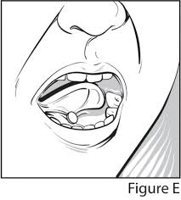
Sublingual medications:

Sublingual medications are placed under the tongue and kept there until dissolved (not chewed or swallowed).

Wait at least 30 minutes before eating or drinking.

accessdata.fda.gov/drugsatfda

Buccal medications:

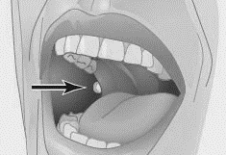
Buccal medications are placed between the gums/teeth and cheek and kept there until dissolved.

Wait 30 minutes before eating or drinking.
nursing-skills.blogspot.com/2013/12

Liquid forms of medications:

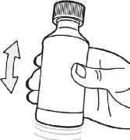
Often used for those who have difficulty swallowing.

Check to see if a liquid medication must be shaken before use and if so, vigorously shake the bottle for 15 to 30 seconds each time it is given.

Do not mix different liquid medications together before giving. https://labeling.pfizer.com/

ShowLabeling.aspx?id=965&section

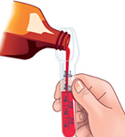
Techniques for measuring liquid medications:

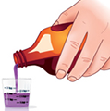
Use a measuring device to be exact:
- Use a calibrated medicine cup, a syringe, or the specific measuring spoon that came with the medication.
- Never use household measuring spoons or safemedication.com silverware spoons as they may not hold the correct amount.
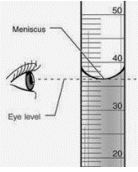
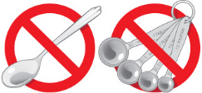
- Pour liquid away from the label – place the labeled side of the container against the palm of your hand to protect the label
safemedication.com from drips and runs.
- If using a measuring cup, set the cup onto a surface and pour the liquid to the desired amount at eye level.
Pour slowly and stop when the desired level is reached. The lowest part of the “meniscus” (the lowest part of the “U” shape formed by the liquid) is the correct level.
Ohio DDD Med Certification Manual

medications absorbed through skin/membranes

Transdermal medications:

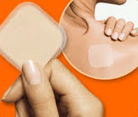
The medication is contained in sticky patches applied onto the skin for a certain amount of time, such as for a day or a week.
- If ordered daily, reapply at the same time each day for a continuous delivery of the medication.

When applying:
- Wear gloves.
- Alternate sites to prevent skin irritation.
- Clean and dry skin before applying.
- Do not apply over scars, folds, or wrinkles, or on irritated skin.

Remove carefully so as not to tear the skin: clean and dry the area.

Lotions, creams, ointments, and drops

Vaginal and rectal medications

inhaled medications

Metered dose inhaler (MDI):
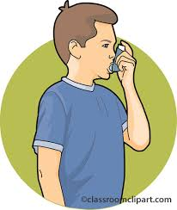
- When the person pushes down on the aerosol container, a “puff” of medicine is released.
- These may be used with a spacer or holding chamber to make it easier to use. The spacer eliminates the need to coordinate inhaling while pushing down on the inhaler.

Dry powder inhaler (DPI):
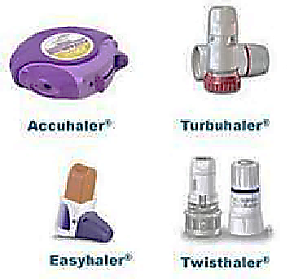
- Delivers medication in powder
form but doesn’t spray out.
- The user must inhale the
powdered medicine quickly and
forcefully.

Ohio Dept of Developmental Disabilities Med Cert. Manual

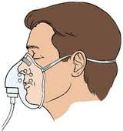
Nebulizer:
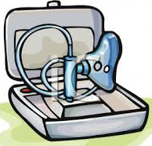
- Used when a larger amount of medication is needed or when a person is not able to use an inhaler.
- Nebulizers turn liquid medicine into a fine mist that is inhaled into the lungs. The user breathes in the mist through a mouthpiece or facemask.

Supplemental oxygen (o2)
- Can be considered a “medication”.
- Helps decrease shortness of breath and fatigue.
- Is given via nasal cannula or by mask.
- Is supplied by an oxygen tank or a concentrator.
- Is ordered in liters (L) per minute such as 2L/min.
- Is a safety hazard as it is highly flammable.

Oxygen Safety:

NO SMOKING WHILE RECEIVING OXYGEN THERAPY
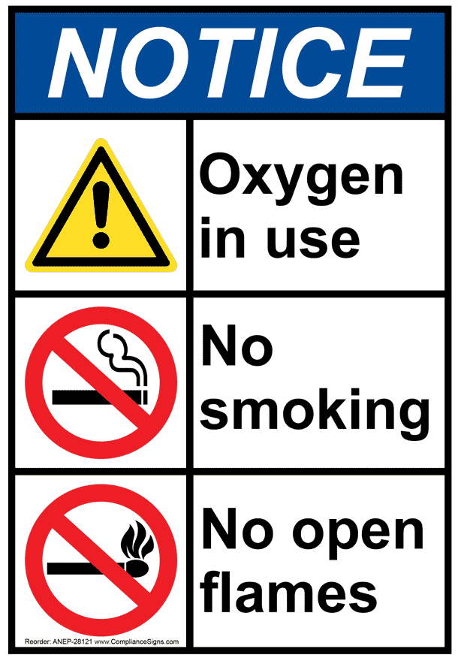
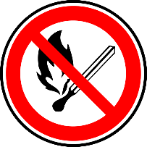
- Anyone on oxygen may not be in a room where there is a flame.
- Avoid materials that cause static electricity.
- Do not use acetone or other volatile material near oxygen.

Side effects of oxygen therapy:
- Fatigue, morning headaches.
- Dry and/or bloody nose.
- Skin irritation from face mask or nasal cannula.

What care does the person need?
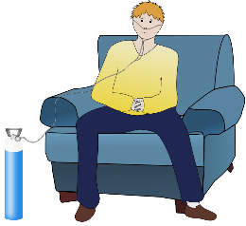
- Protect the person’s nose, face, and ears from irritation caused by the nasal cannula or face mask.
- Use a water-based lubricant (such as K-Y®) where the mask or cannula rub the face, nose, or ears. Vaseline® (petroleum jelly) is NOT water based.
- Be sure to strictly follow safety measures to prevent fire or explosions.
- Provide frequent opportunities for the person to drink fluids to keep mouth and throat moist.

Signs of receiving too little oxygen:
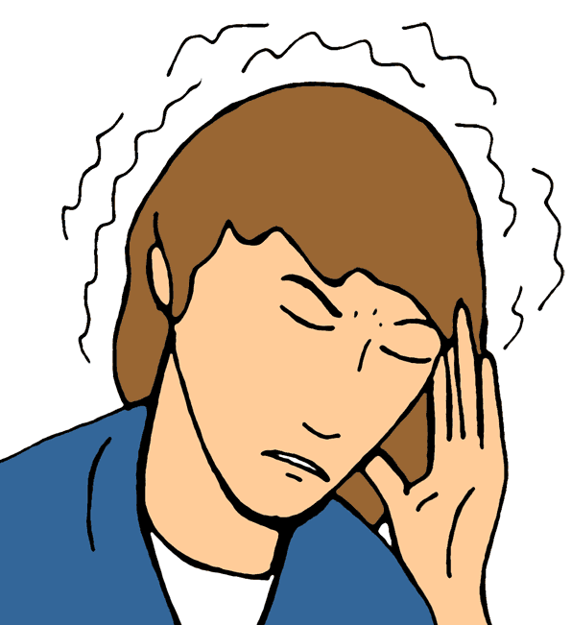
- Confusion, restlessness, excessive tiredness.
- Rapid heart rate, elevated blood pressure.
- Rapid breathing or shortness of breath.
- Headache, blurred vision, tunnel vision.
- Cyanosis (bluish tint to the lips or nailbeds).

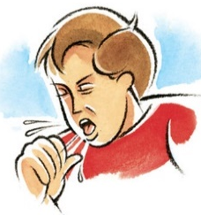
Signs of receiving too much oxygen:
- Slow respiratory rate (under 8 breaths/minute) or difficulty waking up.
- Coughing from irritation of the airways.
- Tunnel vision.
- Ringing in the ears.
- Nausea, dizziness.
See Appendix 4. MEDICATION FORMS and ADMINISTRATION for more information

Chapter 5. ADMINISTRATION OF MEDICATIONS

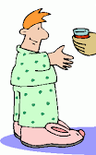
Before administering medications, you need to know

The purpose of the medication – why is it being given.

The dosage (how much, how often).

Special instructions such as:
- With food or on an empty stomach.
- If certain foods should be avoided, etc.

What to do if a dose is missed.

- Specific orders from the prescriber are needed
if the dose can be given late on certain days.

What to do if given incorrectly.

Side effects.

Monitoring such as obtaining blood levels.

standard precautions
Most people use the term “Universal Precautions” regarding the control of the spread of infections, but “Standard Precautions” is the correct term to use.

Standard Precautions:
- apply to blood and all body fluids, secretions, and excretions, except sweat, regardless of visible blood.
- also apply to non-intact skin and mucous membranes.

Body fluids are potential carriers of infectious diseases and should always be treated as though they are contaminated.

In addition to Standard Precautions there are:
- Airborne Precautions
- Contact Precautions
- Droplet Precautions

preventing transmission of infections
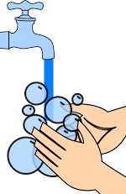
The NUMBER ONE technique to control transmission of infections is by using a hand sanitizer or by hand washing followed by the use of personal protective equipment (PPE).

Hand hygiene:

WASH HANDS or use a hand sanitizer:
- Before preparing medications.
- Before and after contact with an individual.
- Before and after any procedures such as emptying a catheter bag.
- After handling contaminated equipment.
- After removal of gloves.

- After using the toilet or after taking a client to the toilet.
- After handling soiled laundry.
- After smoking.

Important points to decontaminate hands effectively:
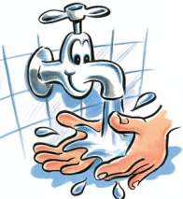
- Cover any cut or abrasion with a waterproof dressing.
- Keep natural nails short, clean, and unpolished.
- Do not wear false nails.
- Remove or roll up long sleeves when washing hands.
- Remove any wristwatch, stoned ring, or bracelet.

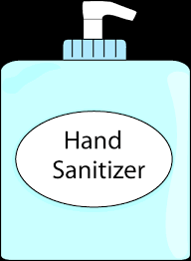
ALCOHOL-BASED HAND SANITIZERS:
- Are preferred for use after contact with an individual or their environment but hands should be visibly clean before using.
- If hands are visibly soiled, they must be washed with soap and water.
- Alcohol-based sanitizers should contain at least 60% alcohol.
- These will not prevent the transmission of some infectious agents including C. difficile and norovirus.

Personal protective equipment (PPE):

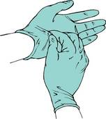
Gloves:
- Should be disposable, non-powdered latex or latex equivalent (not vinyl or plastic).
- Use when there is a possibility of contact with blood or body fluids such as when:

assisting clients with bathing or mouth care.

handling laundry that is soiled with body fluids or blood.

obtaining a specimen (urine, stool).

changing any bandage.

providing skin care.

helping with shaving.

treating cuts, bites, nose bleeds, burns, insect stings.

cleaning emesis.
- Sanitize hands before putting on gloves and after their disposal.
- Change gloves before assisting with a different individual.
- Dispose of gloves following their use for any procedure.

Aprons or gowns – should be disposable
- Wear when there is any possibility of contact with body fluids.

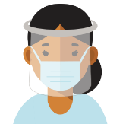
Eye shields
- Wear when there is the possibility of droplets from a person coming into contact with the eyes; especially when the person is coughing or sneezing and is unable to wear a mask.
- Especially important if giving a med neb treatment.

Waste bags

- Wear personal protective equipment (PPE) when dealing with waste.
- Do not overfill bags (no more than 2/3 full).
- Label to identify place of origin.
- Store in a designated area until collected.

Management of minor blood spills:

Gloves and aprons or gowns should be worn.

All blood spills or splashes of blood should be dealt with immediately.

Use absorbent material such as paper towels to soak up spills.

Wash the area with hot water and appropriate cleanser.

Gloves and aprons or gowns must be double bagged for disposal.

Wash hands after removal of PPE.

the rights of medication administration
All medications must be prepared and administered according to the “7 rights”:
- Right individual or person
- Right medication
- Right dose
- Right time and date
- Right route
- Right position
- Right form (consistency, texture, e.g., crushed, mixed with food)

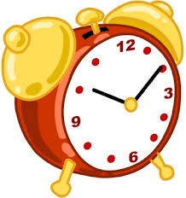


The right PERSON:


Why is this important? If a medication is given to the wrong person, it could cause harm or even death. The wrong medication:
- May cause an allergic reaction.
- May react with other medications.
- May work in a way that is harmful, i.e.:

A medication that lowers blood pressure could lower it to a dangerous level in a person who has normal blood pressure.

A medication that lowers blood sugar, could cause the blood sugar level to fall dangerously low if given to the wrong person.

To make sure that you give medication to the right person, you must know that person or have a way to identify him or her.

To avoid this serious mistake:
- Prepare medications for one person at a time.
- Give a medication to the individual as soon as you prepare it.
- Do not become distracted by conversing with others or stop to do something else while in the middle of giving medications.

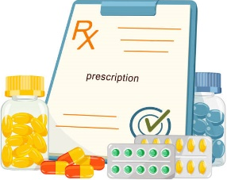
The right MEDICATION:

Read the label (note brand/generic names).

Read the order/prescription (if available) carefully making sure that it matches the label.

Read the Medication Administration Record (MAR) carefully, making sure that the medication name on the label and the MAR match.

Look at the medication: note any difference in size, shape, or color from the medication that you usually give. Sometimes a different generic brand is provided by the pharmacy that is the same medication, but it looks different. However, it also could mean that it is the wrong medication.

The right DOSE:

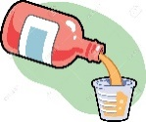
The dose is how much of the medication is given at one time.
- To determine the dose, know the strength of the medication. For liquid medications, know the strength of medication in each liquid measurement such as mg/ml.
- An order/prescription may state to give Depakote 500 mg twice daily, but the tablets are 250 mg. You would then give 2 tablets twice daily.

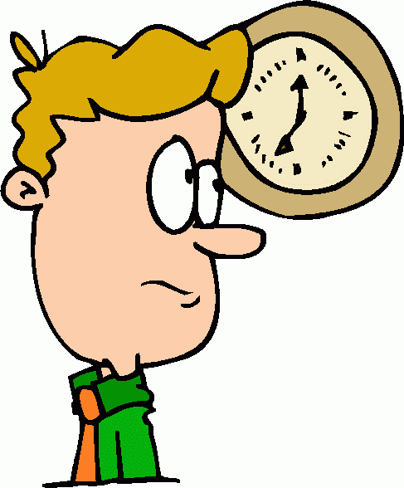
The right TIME and DATE:

Medications must be given within a two-hour time window which means the medication is given between one hour before and one hour after the listed time on the MAR (unless otherwise ordered).
- You may obtain an order to go outside the two-hour
window for certain circumstances such as when a client who normally takes medications at 7 am, likes to sleep in until 10 am on weekends or when a client is going on an outing and a medication would need to be given a bit early. You must have an order from a provider to give medications outside the usual 2-hour window. The order must specify how early or late the medication may be taken and under what circumstances the medication may be given either early or late.
- If a medication is given outside the normal two-hour window, document when the medication was given and why it was given outside the window. If there was no order to give a medication outside the two-hour window, it is considered a medication error.

Note that some medications need to be taken only at specific times such as before meals or at bedtime.

When setting up a client’s medications, make sure that the medication was given on the correct day or date the last time it was administered.
- Some medications are only given on certain days of the week such as Monday, Wednesday, and Friday. Be sure to give medications on the correct day.

The right ROUTE:

The right route means how and where the medication goes into or onto the body.

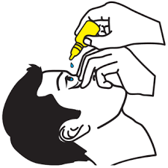
Most medications are taken by mouth and swallowed; but others enter through the skin, rectum, vagina, eyes, ears, nose, and lungs. Some are given through a gastric tube or by injection.

Make sure to compare the route on the prescription label, the medication order, and the MAR before giving a medication.

When given by the wrong route, harm may occur to the individual. For example, if a medication that is meant to be placed in someone’s ear, is put into the eye, serious damage could occur to the eye.


The right POSITION:

Depending upon the type of medication given and where it is given or applied, you will need to position the person in the appropriate way. For example:
- When giving an oral medication, the person should be sitting as upright as possible to make it easier to swallow and to prevent reflux or aspiration.
- If administering eye drops, the person should be
able to tilt the head slightly upward.


The right FORM:

To ease swallowing, a medication may need to be crushed and mixed with food. Make sure the “consistency” of the medication is correct.

DOCUMENTATION:

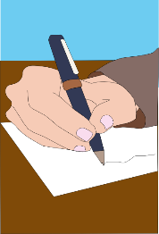
Another “right” of medication administration is the “right documentation”. Each time a medication is administered in any way, it must be documented on the MAR, at the time it was given, NOT LATER, NOT BEFORE!

In order to document that a medication was given, it means you:
- saw the person swallow the medication, or
- observed the person to inhale the medication, or
- administered drops or other topical medications to the right spot or witnessed the person doing so.

Always document each medication administered on each person immediately. Do not go back and fill in the MAR after you have finished helping all the clients with their medications.

You cannot document medications that another staff person administered. Only document the work that you do.

To document on the MAR:
- Use blue or black ink; no pencil or liquid eraser can be used.


- Never cross out, erase, or write over documentation.
- If you make a mistake, circle your mistake, and write a note on the correct area of the MAR to explain what
happened.

preparation Before giving medications

Prepare and administer medications for only one person at a time!

Give your full attention to preparing medications.

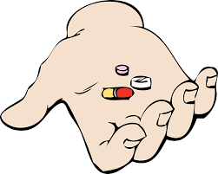
Check the MAR to see when the last dose was given and when the next dose is due. If you find that a medication was not given, investigate and report.

Never place any oral medication (tablet, capsule, etc.) into your own bare hand. Always transfer oral medications from the container into a cup.
- All oral medications (other than liquid medications) that are for one person can go into one cup, unless otherwise specified.

Never take medications from unlabeled containers.

Never prepare medications before it is time for them to be taken. They cannot be left in the dispensing cup to be given later.

Never administer medications that have been prepared by someone else under any circumstances.

Check the individual’s MAR –
EVERY MEDICATION, EVERY PAGE, EVERY DAY!

giving or applying medication

The person giving or applying a medication must follow the Seven Rights of Medication Delivery for every medication given.

For oral medications, stay with the person until the medication is taken and make sure that it is swallowed.
- You cannot document that an oral medication was taken unless you see that it was swallowed.

Medications are to be given and documented by the person who prepared the dose(s).
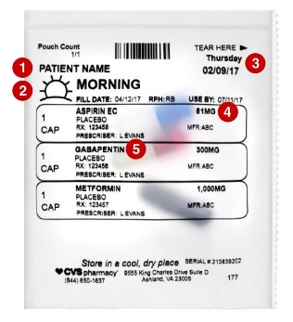
- NEVER give any medication set up by another person.

Give medications from containers:
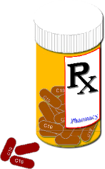
- that have an intact pharmacy label if a prescription drug.
- that have an intact manufacturer’s
label if a non-prescription drug.

steps for medication administration

Clean hands with a hand sanitizer or wash hands.


Starting at the beginning of the MAR, check:

Person’s name.

Medication(s) ordered.

Medication(s) to be given now.

That the previous dose was given.

That this dose has not yet been given.

For any special instructions.

Get the medication(s) from the secure storage area.

Confirm the entire drug name, strength and dose of the medication(s).

Read the entire label carefully including the expiration date and special instructions. Make sure the description of the drug matches the drug inside the container.

Check that the MAR matches the drug label:

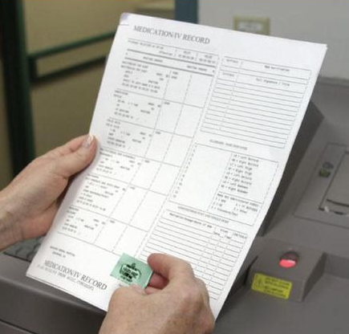
Place the medication container beside the name of the drug on the MAR.

Make sure the container and the MAR match exactly.

Confirm the first 5 rights (person, medication, dose, time, route).

If they do not match, do not give the medication until there is clarification from a healthcare record or healthcare professional regarding the medication. If they do match, go to the instructions for giving the medication(s) according to the type of medication or route taken.
,
These apply to all medications
regardless of the route given and must be done
EVERY TIME for EVERY MEDICATION

See Appendix 5. ADMINISTRATION OF MEDICATIONS for more information.

Chapter 6. DOCUMENTATION


The abc’s of charting
A. ACCURATE
B. BRIEF
C. COMPLETELY OBJECTIVE

the Medication Administration Record (MAR)


The MAR is used to document all medications taken.

A MAR includes:

Medication names and doses.

Time/dates for taking the medication.

A place to initial that the medication was taken.

Electronic MARs are used by some organizations. The basic rules for charting must still be observed though the procedure will differ.

Transcribing

Taking the information from a medical provider’s orders/prescription and transferring them to the MAR is known as “transcribing”.
- Some pharmacies provide completed MARs.
- You may need to add a new medication to your current MAR.
- You may need to make changes to the MAR if a dose of medication is changed or a medication is stopped.

charting rules for use of a paper Mar


The medication column should be completed by an authorized person. Make sure you are familiar with the medications listed, doses ordered, and any abbreviations used.

After assisting with someone’s medications, place your initials below the correct date and opposite the medication that was taken.
- Do this ONLY after you observe that the medication was administered.
- NEVER initial that a medication was given before it is administered and observed to have been swallowed or otherwise administered.

Each MAR must show a signature and the initials used by all staff.

Ditto marks are never used.

Never erase or use any kind of liquid eraser.
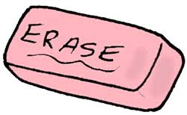

- If you make an error in charting, draw a single line through the error, then initial and date the spot.
- If you make a mistake on the MAR itself, circle the error and explain the circumstances on the
appropriate section of the MAR.

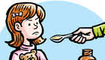
Record onto the MAR immediately and only AFTER you see that the medication was swallowed or otherwise was administered as ordered. This is the only way to be sure that you are charting the right medication, giving it to the right person, at the right time, by the right route, and that you can be

certain that the medication was taken or administered.

If a medication is not taken as ordered for any reason, put your initials in the appropriate box, circle those initials, and note the reason on the back of the MAR or otherwise designated area. Notify the appropriate person.


If the person refuses the medication(s), continue to make attempts to encourage the person but if you are unable to give the

medication within the designated time window:
- Place a circle in the box
- Initial inside the circle
- Chart reason for the refusal in the designated area.
- Notify the appropriate person.
- If the medication was set up, you cannot return it to the container, you must dispose of it.

See Appendix 6. DOCUMENTATION for more information.

Chapter 7. FILLING OUT THE MAR

GENERAL RULES

Filling out the Medication Administration Record (MAR) is simple if you follow these steps:

Write down the information from the prescription in an organized fashion so that you do not make mistakes or forget to record anything.

Transcription errors are common and can be fatal.

Pay close attention to what the prescription or medication container states and how you transcribe it onto the MAR.

If you are unsure of the directions or anything else on the prescription, ask the pharmacist or prescriber to clarify.

Even if the pharmacy provides a completed MAR or you use an electronic MAR, knowing how to fill one out will ensure that you know how to read and follow any MAR correctly.

If you know how to transcribe onto a MAR, you will be better prepared to notice any errors that may be on the MAR.

You may need to transcribe a new, short term medication such as an antibiotic onto a MAR.

If the MAR comes filled out by the pharmacy, make sure you check the orders against what is on the MAR to catch any possible mistakes.
When you take your medication certification test, you will be given information and a prescription similar to the examples shown. You must be able to use this information to fill out the MAR correctly. You will not be given any assistance with any portion of the test, so you must understand the steps to filling out a MAR in order to pass.

why learn how to fill out a paper MAR?

Electronic Medication Administration Records (eMAR) or Electronic Medication Management systems (EMM) are becoming more widely used.

They may help reduce human error, however, since a human is involved in putting information into them, errors can still occur.
- Each month you should review the record to make sure everything is correct. Knowing how to fill out a standard paper MAR will make this task easier.

They often make the refilling process easier.

They may give more information about each medication, including how it appears, making it easier to check that the correct pill has been sent.

They can decrease the time spent on documentation. However:
- You must still document on the eMAR only after the medication has been administered.
- Never document before giving a medication.
- Never wait to document until after giving medications to all clients.

Disadvantages to eMARs or EMMs:

Many eMARs or EMMs store sensitive patient information in the cloud which puts the data at risk for being hacked without sufficient layers of security.

If a technical error occurs and the data is not sufficiently backed up, all data may be lost.

If the eMAR or EMM is not available because the internet is down or there is some problem such as a computer issue, you will need to have a backup process in order to be able to administer medications.

They can be costly.

They may be difficult for staff to be trained on or to adapt to using.

Emergency readiness binder:

To address medication safety concerns, an emergency readiness binder that is both available electronically and in physical form (hard copy) should be compiled. This will then be available for use if the system for the eMAR or EMM goes down or if there are computer issues that make it impossible to use the electronic record.

The eMAR should be backed up onto a computer and printed each month so that a copy of medications that need to be given is available.

A system for communicating with the pharmacy for new medications, refills, etc. will need to be developed.




Abbreviations

You must know the basic abbreviations used and be able transcribe onto the MAR without using the abbreviations (except those listed in #2).

Approved abbreviations to use on a MAR include: mg (milligrams), g (grams), mcg (micrograms), ml (milliliters) and l (liters). Others such as BID must be written out.

ABBREVIATIONS for the times of day
BID | - means a medication is given twice a day during normal awake hours, not at exact intervals over 24 hours  - does not mean 12 hours apart, but rather, in the morning and in the evening
TID | - means a medication is given three times a day during normal awake hours  - does not mean 8 hours apart but means three times during the day: morning, mid-day, and evening
QID | - means a medication is given four times a day during normal awake hours  - does not mean every 6 hours but rather it is given at close to equal times apart throughout a normal day while awake.
2 qd or two daily | - means that two tablets (or capsules, etc.) are given together once during the day.  - it does not mean to give one tablet twice during the day (that would be written as BID)
3 qd or three daily | - means to give three tablets together once during the day  - it does not mean to give one tablet three times during the day (that would be TID)
q 4 hrs  or every 4 hours | - medications may be prescribed for every 4 hours (or any other interval)  - the person may need to be awakened to take medications if written this way unless the prescription states “while awake”.
q am | - “q” means “every” so “q am” means every morning.  - when a medication is ordered for only certain days of the week, then “q am” refers to “in the morning” on those days that the medication is ordered  - for example, “q am twice weekly” would translate to “in the morning twice a week” or “in the morning on Monday and Thursday”.  - the same rules hold true for qd (every day), q pm (every evening) and q hs (every bedtime or night)

dosing schedules

Based on the schedule in the group home or the person’s own schedule, you may need to decide at what time medications are to be taken by a person if you are filling out the MAR. Usually, the pharmacy has this already filled out. If not, use the following guidelines.

FREQUENTLY USED DOSING TIMES
Abbreviation | AM | Daytime hours | Daytime hours | PM
BID | 6, 7, 8 |  |  | 6, 7, 8
TID | 6, 7 | 12, 1 |  | 7, 8
QID | 6, 7 | 11, 12 | 3, 4 | 8
q am | 6, 7
q pm |  |  |  | 5, 6, 7
q hs |  |  |  | 7, 8, 9

FREQUENTLY USED DOSING TIMES FOR SPECIFIC INTERVALS
q 6 hrs – or every 6 hours | 6 am, 12 noon, 6 pm, midnight, or  7 am, 1 pm, 7 pm 1 am
q 8 hrs – or every 8 hours | 6 am, 2 pm, 10 pm, or  7 am, 3 pm, 11 pm

FREQUENTLY USED SCHEDULES FOR

INTERMITTENT MEDICATION DOSING
2/wk. or 2 x (times) per week or  twice weekly, etc. | Monday and Thursday, or  Tuesday and Friday, or  Wednesday and Saturday or Sunday
3/wk. or 3 x per week or three times weekly, etc. | Monday, Wednesday, and Friday (MWF), or  Tuesday, Thursday and Saturday or Sunday (TThS)
4/wk. or 4 x per week or  four times weekly, etc. | Saturday, Sunday, Tuesday, and Thursday (SSTTh)

step-by-step: filling out the mar
Example:
Joe Smith saw Dr. Davis because of a runny nose and cough. He was diagnosed with bronchitis and allergic rhinitis. A prescription was written for two medications. You pick up the medications at 2 pm on January 3. After comparing the prescription to the information from the pharmacy, you transcribe the medications onto the MAR and give the first dose of Zithromax. Joe is allergic to penicillin. Using the prescription below, fill out the MAR.

Davis and Hartman Medical Group, PLLC
1011 Jackson
Helena, MT 59601
406-442-6779
January 3, 2018
Joe Smith Birthdate: 11/16/58
Rx:

Allegra 60 mg
Sig: one tablet po BID
Disp: 60
Refill x 1 year

Zithromax 250 mg
Sig: two tabs po today, then one tablet po qd until gone
Disp: 6

Signed: Ron Davis, MD
Ron Davis, MD

Medication: Allegra, dose = 60 mg.

Write this under the “medication” column.
Medication | Jan | HR | 1 | 2 | 3 | 4 | 5 | 6 | 7 | 8 | 9 | 10
Allegra | start
60 mg

Instructions (sig): one tab po bid = one tablet (or capsule) by mouth twice daily.

Transcribe those instructions to the first column:
Medication | Jan | HR | 1 | 2 | 3 | 4 | 5 | 6 | 7 | 8 | 9 | 10
Allegra | start
60 mg, one tablet
by mouth
twice daily

Start date. Under the column marked “Jan” for January, you would write 1/3/18 as the start date. This is because:

The prescription date is January 3.

You picked up the medication in the afternoon so there is no reason for the person not to take the first dose of the medication on that day.

There are no specific instructions on the prescription that state to start the medication on another day.

Fill in the “HR” or hour(s) that the medication is to be taken.

For this example, use 7 am and 7 pm.
Medication | Jan | HR | 1 | 2 | 3 | 4 | 5 | 6 | 7 | 8 | 9 | 10
Allegra | start | 7am
60 mg, one tablet | 1/3/18
by mouth |  | 7pm
twice daily

Block out dates:

Block out the dates before starting the medication by using an “X” or putting a line through them.

Since the medication started later in the day on January 3, you would block out the days prior to the date the medication is first given.

Leave open boxes for the dates and times that the medication is to be given.
- These are the spaces for confirming that the medication was given.
- In some cases, this may be through the end of the month. In this case, since the prescription does not indicate a “stop date”, the medication is to be given every day in January starting on January 3 and continue each month until it is discontinued.

If using a paper MAR, there will be a place for staff to write their names and initials to identify who assisted with medications at those times.
Medication | Jan | HR | 1 | 2 | 3 | 4 | 5 | 6 | 7 | 8 | 9 | 10
Allegra | start | 7am | X | X | X
60 mg, one tablet | 1/3/18
by mouth |  | 7pm | X | X
twice daily

The second medication, Zithromax.

Since this is given in two different ways, i.e., 2 tablets today and then one tablet daily until gone, you must write the medication and dose in two separate places.

Each place will have the different set of instructions.
Medication | Jan | HR | 1 | 2 | 3 | 4 | 5 | 6 | 7 | 8 | 9 | 10
Zithromax | start
250 mg, 2 tablets
by mouth
today, then
Zithromax | start
250 mg, 1 tablet
by mouth daily
until gone

Start dates:

Since the first set of dosing instruction states “today”, you would put 1/3/18 in the correct spot.

This then means that the second set of dosing instructions starts on the following day which would be 1/4/18. However, it is also not incorrect to put in 1/3/18 in that place also as that shows when the medication was first started at any dose.
Medication | Jan | HR | 1 | 2 | 3 | 4 | 5 | 6 | 7 | 8 | 9 | 10
Zithromax | start
250 mg, 2 tablets | 1/3/18
by mouth
today, then
Zithromax | start
250 mg, 1 tablet | 1/4/18
by mouth daily
until gone

Hour (HR):

The first dose is given “today”.

To determine the time, look at the information provided which states that the medication was picked up at 2 pm. Since it is an antibiotic, giving it as soon as possible is reasonable, therefore, giving the medication at 3 pm would be an appropriate time.

The remaining doses of Zithromax are to be given “daily”.
- This generally means that the medication would be given in the morning so 7 am would be appropriate.
- However, since it was started at 3 pm on the previous day, using 3 pm would not be incorrect either.
Medication | Jan | HR | 1 | 2 | 3 | 4 | 5 | 6 | 7 | 8 | 9 | 10
Zithromax | start | 3 pm
250 mg, 2 tablets | 1/3/18
by mouth
today, then
Zithromax | start | 7am
250 mg, 1 tablet | 1/4/18
by mouth daily
until gone

Block out dates:

Block out the dates before the medication is first started, and after the medication ends.

The first dose is taken on 1/3 therefore all days prior to 1/3 are blocked out with an X or a line.

The second set of instructions after the first day is for “1 tablet daily until gone”.
- You know that this dose starts on 1/4 and by looking at the prescription you see that 6 tablets were prescribed. Two tablets were used on 1/3, there are 4 tablets left (4 days to give the medication). This means that all days prior to 1/4 and after 1/7 are blocked out.

This medication is given for a known length of time, so you can add a stop date.
Medication | Jan | HR | 1 | 2 | 3 | 4 | 5 | 6 | 7 | 8 | 9 | 10
Zithromax | start | 3pm | X | X |  | X | X | X | X | X | X | X
250 mg, 2 tablets | 1/3/18
by mouth
today, then
Zithromax | start | 7am | X | X | X |  |  |  |  | X | X | X
250 mg, 1 tablet | 1/4/18
by mouth daily | stop
until gone | 1/7/18

Another notation that can be made on the MAR when a drug is given for a limited number of days is to place the number (1 through 4) in this case for the 4 days the medication is given once daily under the boxes that would be initialed by staff after giving it. This can act as a double check.
Medication | Jan | HR | 1 | 2 | 3 | 4 | 5 | 6 | 7 | 8 | 9 | 10
Zithromax | start | 3 pm | X | X |  | X | X | X | X | X | X | X
250 mg, 2 tablets | 1/3/18
by mouth
today, then
Zithromax | start | 7am | X | X | X |  |  |  |  | X | X | X
250 mg, 1 tablet | 1/4/18 |  |  |  |  | 1 | 2 | 3 | 4
by mouth daily | stop
until gone | 1/7/18

Below is the completed MAR for the two medications prescribed on 1/3 and shows that the first dose of Zithromax was given by George Peters.
The MAR should also contain the name of the client, physician, diagnosis, and allergies (you will not be asked to fill those out on the test).
Medication | Jan | HR | 1 | 2 | 3 | 4 | 5 | 6 | 7 | 8 | 9 | 10
Allegra | start | 7 am | X | X | X
60 mg, 1 tablet | 1/3/18
by mouth |  | 7 pm | X | X
twice daily
Zithromax | start | 3 pm | X | X | gp | X | X | X | X | X | X | X
250 mg | 1/3/18
2 tablets
by mouth today
Zithromax | start | 7 am | X | X | X |  |  |  |  | X | X | X
250 mg, 1 tablet | 1/4/18 |  |  |  |  | 1 | 2 | 3 | 4
by mouth | stop
daily until gone | 1/7/18

Diagnosis: allergic rhinitis, bronchitis

Allergies: | Penicillin |  | IN | Name: | IN | Name:
Name: | Physician: | Phone # | NR | Noel Ranger | HT | Hillary Thomas
John Smith | Ron Davis | 442-6779 | gp | George Peters
DOB: 11/16/58

See Appendix 7. FILLING OUT THE MAR for more examples. Make sure you practice these as you will be asked to fill out a MAR on the test.

Chapter 8. MEDICATION ERRORS
Medication errors can occur despite everyone’s best effort to avoid them. What is important is recognizing them when they occur and dealing with them appropriately.

types of medication errors


Giving medication to the wrong person.

Giving the wrong medication.

Giving an incorrect dose.

Giving medication at the wrong time or on the wrong day.

Giving medication by the wrong route.

Giving medication in the wrong form.

Giving expired (outdated) medication.

Giving medication without an order.

Omitting medication (forgetting to give a medication).

Failure to document a medication refusal.

Failure to document that a medication was given.

Giving medication that was stored improperly (potency may be affected).

why do medication errors occur?

Not checking the label against the MAR during preparation.


Reading the label or MAR incorrectly.

Forgetting to give a medication.

Not waiting to see if the individual swallowed an oral medication.

Not documenting immediately after the medication is given (after you see it swallowed for oral medication).

Error in transcribing onto the MAR – can occur at the pharmacy or in the group home.

A new medication was not transcribed onto the MAR and thus not given.


Incorrect documentation of medication given.

Multi-tasking while setting up medications – not giving it your full attention.

Environmental distractions.

Failure to obtain a refill before it has run out.

Failure to pick up a newly prescribed or refilled

medication from the pharmacy.

When a Medication is TAKEN BY the wrong person

If someone accidentally takes the wrong medication or too much of their usual medication, it can have serious consequences, including death, depending on the medication and dose. You must know how to respond immediately, meaning at the very least, the medical provider, pharmacist or Poison Control should be contacted to obtain advice. Most of the time, having the person evaluated at the emergency department is the best course of action.

Even when seen at the emergency department, the person may be discharged after only a few hours. For many medications, the general guidelines for length of monitoring is only 6 hours from when the medication was ingested. However, that is often not nearly long enough depending on the medication that was taken, the dose, what other medications the person takes, and that person’s metabolism rate.

A protocol for monitoring anyone who takes the wrong medication should be in place. You must know just how you and others should monitor the individual and for many medications this means close monitoring for 12 to 24 hours.

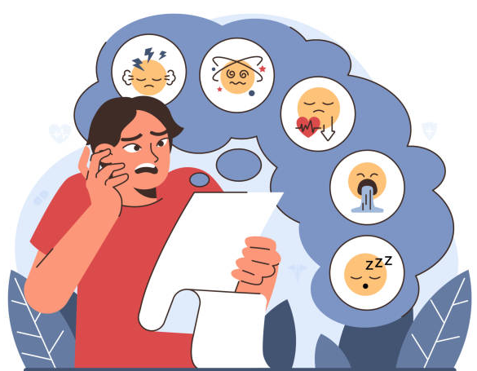
What to monitor: Vital signs: is the oxygen saturation, blood pressure and heart rate at normal levels? Are they running a temperature? Vital signs should be taken as indicated.

Breathing – is it fast, slow, shallow? Does it appear the person is struggling with breathing or short of breath? An oxygen saturation level should be

checked at least every few hours and if the person appears to be having difficulty breathing.


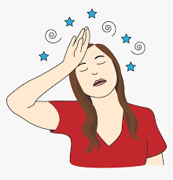
Does the person appear dizzy, unsteady, or complain of dizziness? Is the gait normal or unsteady (ataxic). Is the person nauseated or vomiting.


Is the person confused, lethargic, agitated? Do they respond when someone talks to them? Are they having any fluctuation in alertness such as going from asleep to agitated and back again?

Is the person sweating or shaking? Do they have a tremor or appear very stiff in their movements?

If new symptoms appear or symptoms worsen, the person should be reevaluated, usually at the Emergency Department.

Medications that require closer monitoring than others include:

Antipsychotic medications, especially clozapine

Antiseizure medications, especially lamotrigine and carbamazepine.

Lithium, a mood stabilizer.

Benzodiazepines and opioids, especially long acting or higher potency ones.

Anti-hypertensives, especially high dose long acting ones.

Anticoagulants such as Eliquis as there is an increased risk for excessive bleeding if an injury occurs.

NOTE: For more information on which medications require more monitoring,

refer to Appendix 8.

Missed medications


When a medication is missed or not given on time, consult with a pharmacist, nurse (if available), or the prescriber to find out what to do next. You need to know if you should:

Give the medication late, or

Omit (not give) the medication, or

Follow up with the medical provider for further instructions.

Record any missed medications on the MAR

Initial the spot for the medication on the MAR, then circle your initials.

Write an explanation on the back of the MAR or other appropriate place.

Report the missed medication on an incident form.

reasons medications are not given or taken

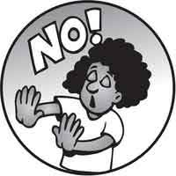
Refusal of the medication.

Client does not like the taste of a medicine.

Client does not like how the medication makes him/her feel

Does not want to be bothered because busy with something else.

Medication is not transcribed to the MAR.


Confusion about how/when to take the medication.

Caregiver or client forgot.

Prescription was not filled/refilled or picked up in a timely manner.

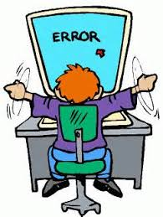


transcription errors
On the certification test, you will be given a prescription and a completed MAR. You must be able to pick out the errors on the MAR using the information provided.

Example #1:
Mary Hunter has epilepsy. She is currently taking Tegretol 400 mg TID and Depakote was recently added. On the morning of February 11, you are about to assist Mary with her medications. As you set up her medications and while checking the medications against the MAR, you notice some problems. Using the prescription supplied, find at least 5 errors. Describe each error on a separate sheet of paper, numbering them 1 through 5 and place that number onto the MAR at the spot where the error occurred.
Davis and Hartman Medical Group, PLLC
1011 Jackson, Helena, MT 59604
406-442-6779

February 2, 2019
Name: Mary Hunter DOB: 6/3/62
Rx:
Depakote 250 mg
Sig: one capsule BID for one week starting tonight,
then increase to 2 capsules BID
Disp: 98 Refill x 1 year

Signed: Ron Davis, MD
Ron Davis, MD

Medication Administration Record
Medication | Feb | HR | 1 | 2 | 3 | 4 | 5 | 6 | 7 | 8 | 9 | 10 | 11
Tegretol 400 mg | start | 7 am | nr | nr | nr | nr | nr |  | tj | tj | tj | tj
by mouth | 6/5/07 | 2 pm | nr | nr | nr | nr | nr | tj | tj | tj | tj | tj
three times daily |  | 8 pm | cp | cp | cp | VL | VL | VL | VL | VL | cp | cp
Depakote 250 mg | start | 7 am | X | X | nr | nr | nr | tj | tj | tj | tj | tj
one capsule by mouth
daily for one week, then
Depakote 250 mg | start | 7 am | X | X | X | X | X | X | X | X | X
one capsule by mouth
twice daily |  | 8 pm | X | X | X | X | X | X | X | X |  | cp

Diagnosis: epilepsy

Allergies: | sulfa | IN | Name: | IN | Name:
Mary Hunter | Dr Ron Davis | nr | Nan Rogers | tj | Tim Jacobs
DOB: 6/3/62 | Phone: 442-6779 | cp | Carol Peters | VL | Val Lawry

ERRORS NUMBERED ON THE MAR
Medication | Feb | HR | 1 | 2 | 3 | 4 | 5 | 6 | 7 | 8 | 9 | 10 | 11
Tegretol 400 mg | start | 7 am | nr | nr | nr | nr | nr | 1 | tj | tj | tj | tj
by mouth | 6/5/07 | 2 pm | nr | nr | nr | nr | nr | tj | tj | tj | tj | tj
three times daily |  | 8 pm | cp | cp | cp | VL | VL | VL | VL | VL | cp | cp
Depakote 250 mg | start | 7 am | X | X | nr | nr | nr | tj | tj | tj | tj | tj
one capsule by | 4, 5 |  |  |  |  |  |  |  |  |  |  | 7
mouth daily 2, |  | 8pm |  | 3 | 3 | 3 | 3 | 3 | 3 | 3
for one week then |  | 4 |  | 4
Depakote 250 mg | start | 7 am | X | X | X | X | X | X | X | X | X | 7
two capsules by | 5
mouth twice daily |  | 8 pm | X | X | X | X | X | X | X | X | 6 | cp

Allergies: | sulfa | IN | Name: | IN | Name:
Mary Hunter | Dr Ron Davis | nr | Nan Rogers | tj | Tim Jacobs
DOB: 6/3/62 | Phone: 442-6779 | cp | Carol Peters | VL | Val Lawry

Tegretol not signed out as having been given on 2/6.

Transcription error: prescription lists BID, MAR states daily.

No evening meds given for 8 doses.

Prescription states Depakote was to start “tonight” on 2/2 but wasn’t given.

No start dates.

Dose changed after 1-week; higher dose to be started on 2/9 for pm dose.

On 2/10, the lower dose was given instead of the higher dose of 2 capsules.
The correct way the MAR should look:
Medication | Feb | HR | 1 | 2 | 3 | 4 | 5 | 6 | 7 | 8 | 9 | 10 | 11
Tegretol 400 mg | start | 7 am | nr | nr | nr | nr | nr | tj | tj | tj | tj | tj
by mouth | 6/5/07 | 2 pm | nr | nr | nr | nr | nr | tj | tj | tj | tj | tj
three times daily |  | 8 pm | cp | cp | cp | VL | VL | VL | VL | VL | cp | cp
Depakote 250 mg | start | 7 am | X | X | nr | nr | nr | tj | tj | tj | tj | X | X
one capsule by | 2/2/19
mouth twice daily |  | 8pm | X | cp | cp | VL | VL | VL | VL | VL | cp | X | X
for one week then
Depakote 250 mg | start | 7 am | X | X | X | X | X | X | X | X | X | tj
two capsules by | 2/9/19
mouth twice daily |  | 8 pm | X | X | X | X | X | X | X | X | cp | cp

Diagnosis: epilepsy

Allergies: | sulfa | IN | Name: | IN | Name:
Mary Hunter | Dr Ron Davis | nr | Nan Rogers | tj | Tim Jacobs
DOB: 6/3/62 | Phone: 442-6779 | cp | Carol Peters | VL | Val Lawry
See Appendix 8. MEDICATION ERRORS for another example.

Chapter 9. TYPES/CATEGORIES OF MEDICATIONS

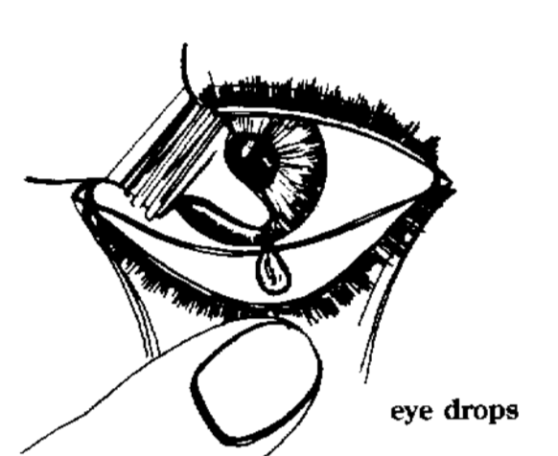
EYE (OPHTHALMIC) MEDICATIONS

Various types including antibiotics, anti-inflammatory drops, and antihistamines.

Can cause redness, watering, swelling, itching, blurred vision.
https://northtexaseyecenter.com/services-
offered/medical-eye-care

Related care:
- Do not share towels and washcloths.

- Keep hands away from eyes.
- Take out contact lenses before use for most.
- Discontinue and contact medical provider if eye pain or changes in vision persist; or if condition worsens.
- Warn person that vision may be blurry for a short
time after use.
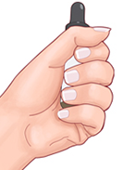
- Refrigerated liquid or gel should be brought to room temperature.

Warm by placing in closed hand for 5 to 10 minutes.

Never put container into microwave, hot water, or warm on a stove.

Do not use solution if cloudy or discolored
safemedication.com/how-to-use-

medication/eardrops

ear (otic) medications

Various types including antibiotics, cleansers, and corticosteroids

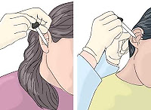
Can cause stinging, burning. Often not recommended when ear tubes in place.

Related care:
- Never place a Q-tip inside ear canal, keep fingers away.
- Encourage use of shower cap to keep water out.
- Hold medication and contact medical provider if drainage occurs or person is complaining of ear pain. nursing-procedures.blogspot.com

nose (nasal) medications

Various types include antihistamines, steroids, and decongestants.

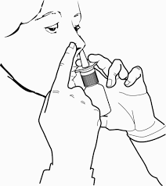
Can cause nasal irritation, bad smell or taste, or dry mucus membranes.

Rhinitis medicamentosa:
- This is due to overuse of OTC decongestant nasal sprays, especially if used for more than 3 to 5 days
in a row.
- Rebound symptoms occur (nasal swelling, drainage) between uses making it difficult to discontinue. In other words: “you’re hooked”.

TOPICAL medications

SKIN MEDICATIONS (ANTIFUNGALS) used for:


Pityriasis versicolor (Tinea versicolor) – yeast on skin causing hypo or hyperpigmentation.

Intertrigo – yeast infections in skin folds.

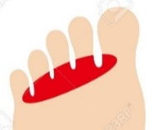
Ringworm – Tinea corporis.

Jock itch – Tinea cruris. https://www.freepik.com

Athletes foot – Tinea pedis.

Vaginal yeast infection – Candida.

Nail fungus – onychomycosis.

RECTAL MEDICATIONS: various types used to treat nausea/vomiting, pain, and fever.

Can cause sedation, dizziness, blurred vision, dry mouth, GI upset.

Suppositories – often used to relieve chronic constipation by stimulating intestinal action and softening stool.
- Can cause nausea, vomiting, abdominal cramps.

Hemorrhoidal – (creams, ointments, suppositories or pads) used to relieve itching and burning from hemorrhoids.
- Can cause redness, burning, allergic reaction, rectal bleeding.

VAGINAL MEDICATIONS - various types used for fungal infections, bacterial infections, and for lubrication.

Can cause burning, itching, stinging.

Do not use topical medications containing cortisone (steroids) on vaginal mucosa or in peri-area.

inhaled medications

Bronchodilators – used to relax airway muscles, making breathing easier

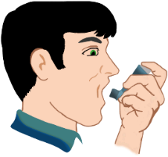
Rescue inhalers such as albuterol work quickly for

fast relief of symptoms.

Maintenance inhalers: work slower but last longer to control symptoms.

Steroid inhalers - used for maintenance treatment for COPD and other chronic lung disease and for short term use of treatment of acute respiratory illnesses.

Related care: rinse mouth after use to prevent oral thrush (yeast).

ANALGESICS

Nonsteroidal anti-inflammatory drugs (NSAIDs):

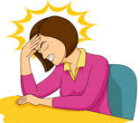
Relieve pain and reduce inflammation.

For mild to moderate pain – headache, joint pain, etc.

Include aspirin, ibuprofen, naproxen, meloxicam, etc.

Side effects include:
- Stomach upset, indigestion.
- Increased bleeding due to effects on platelets.
- Ringing in the ears from high dose aspirin.

Problems associated with long-term use:
- Bleeding ulcers; liver and kidney damage.

Acetaminophen (Tylenol®):

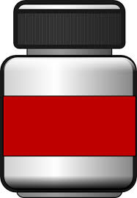
Used to treat mild to moderate pain and fever.

Has NO anti-inflammatory effects.

Side effects include:
Tylenol
- Rash, upset stomach, vomiting.
- Headache, trouble sleeping.
- Elevated glucose levels and uric acid levels (which can cause gout).

Warnings/precautions:
- Can cause liver damage especially in an acute overdose or with chronic daily use.
- Dosage should never exceed 4000 mg daily. It is strongly recommended that dosage should be limited to 2000 mg daily or less especially with frequent use.
- Often combined with decongestants and other cold medications and narcotics therefore it is easy to exceed recommended doses.
- Chronic use of higher doses can cause kidney damage.

Tramadol (Ultram®):

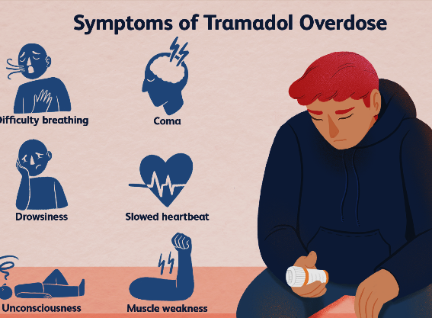
Unique medication as it acts on pain receptors as well as inhibits reuptake of serotonin/norepinephrine (the same mechanism used by some antidepressants).

Side effects include:
- LOWERS SEIZURE THRESHOLD – meaning that not only can someone with a seizure disorder have more seizures but someone who has never had a seizure, may have one.
- Stomach upset, nausea, vomiting, constipation. verywellmind.com
- Dizziness, headache, insomnia, flushing.

Opioids (narcotics):

Effect many receptors in the body to relieve pain.

Have other effects on the body including:
- bradycardia (slow heart rate) ▪ sedation, respiratory depression
- euphoria ▪ physical dependence

Come in a variety of preparations and can be given:
- orally and rectally.
- by intramuscular injection or intravenously (in a vein).
- by transdermal route (through the skin).
- by mucosal route (nasal and oral sprays).
- directly into the spinal canal.

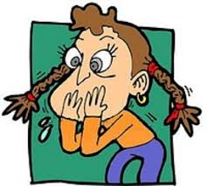
Side effects include:
- nausea, vomiting, constipation
- low blood pressure, bradycardia
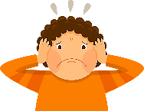
- sedation, confusion, agitation, anxiety
- anorexia (loss of appetite)
- seizures (narcotics lower the seizure threshold)
- respiratory depression and bronchospasm
- weakness

Consider requesting Narcan nasal spray to have on hand if for some reason the person gets too much opioid medication.
See Appendix 9. Types/Categories of Medications for more information.

Chapter 10. MEDICATIONS FOR PSYCHIATRIC CONDITIONS
The incidence of mental illness among people with intellectual disabilities has been estimated to be at least 30-40%. In choosing treatment, the rights of the person to receive appropriate care and treatment in the least intrusive manner must be recognized. The person also has the right to be free from unnecessary chemical or physical restraint.
Medications which are prescribed to improve a person’s mental health, or their behavioral symptoms of mental illness, are referred to as psychotropic medications. The five main groups of psychotropic medications are listed below. However, if used for psychotropic purposes, anti-convulsants, cardiac medications, anticholinergics, and anti-Parkinson drugs are considered psychotropic medications.
Five main groups of psychiatric medications:
Type of medication
Antidepressants | Used to treat disorders such as major depression, dysthymia (persistent mild depression), anxiety disorders, eating disorders and borderline personality disorders.
Antipsychotics | Used to treat psychotic disorders such as schizophrenia and psychotic symptoms occurring in other disorders such as mood disorders.  Also used in the treatment of bipolar disorder and for augmentation in major depression.
Anxiolytics | Used to treat anxiety disorders and include hypnotics and sedatives.
Mood stabilizers | Used to treat bipolar disorder and schizoaffective disorder
Stimulants | Used to treat disorders such as ADHD and narcolepsy

ANTIDEPRESSANTS: Serotonin Syndrome

Serotonin:

Is made by the body and used by the brain and other nervous system cells to communicate with each other.
- It is responsible for regulating the nervous system including body temperature, muscle tone, and gut motility.

Lack of enough serotonin plays a role in depression.

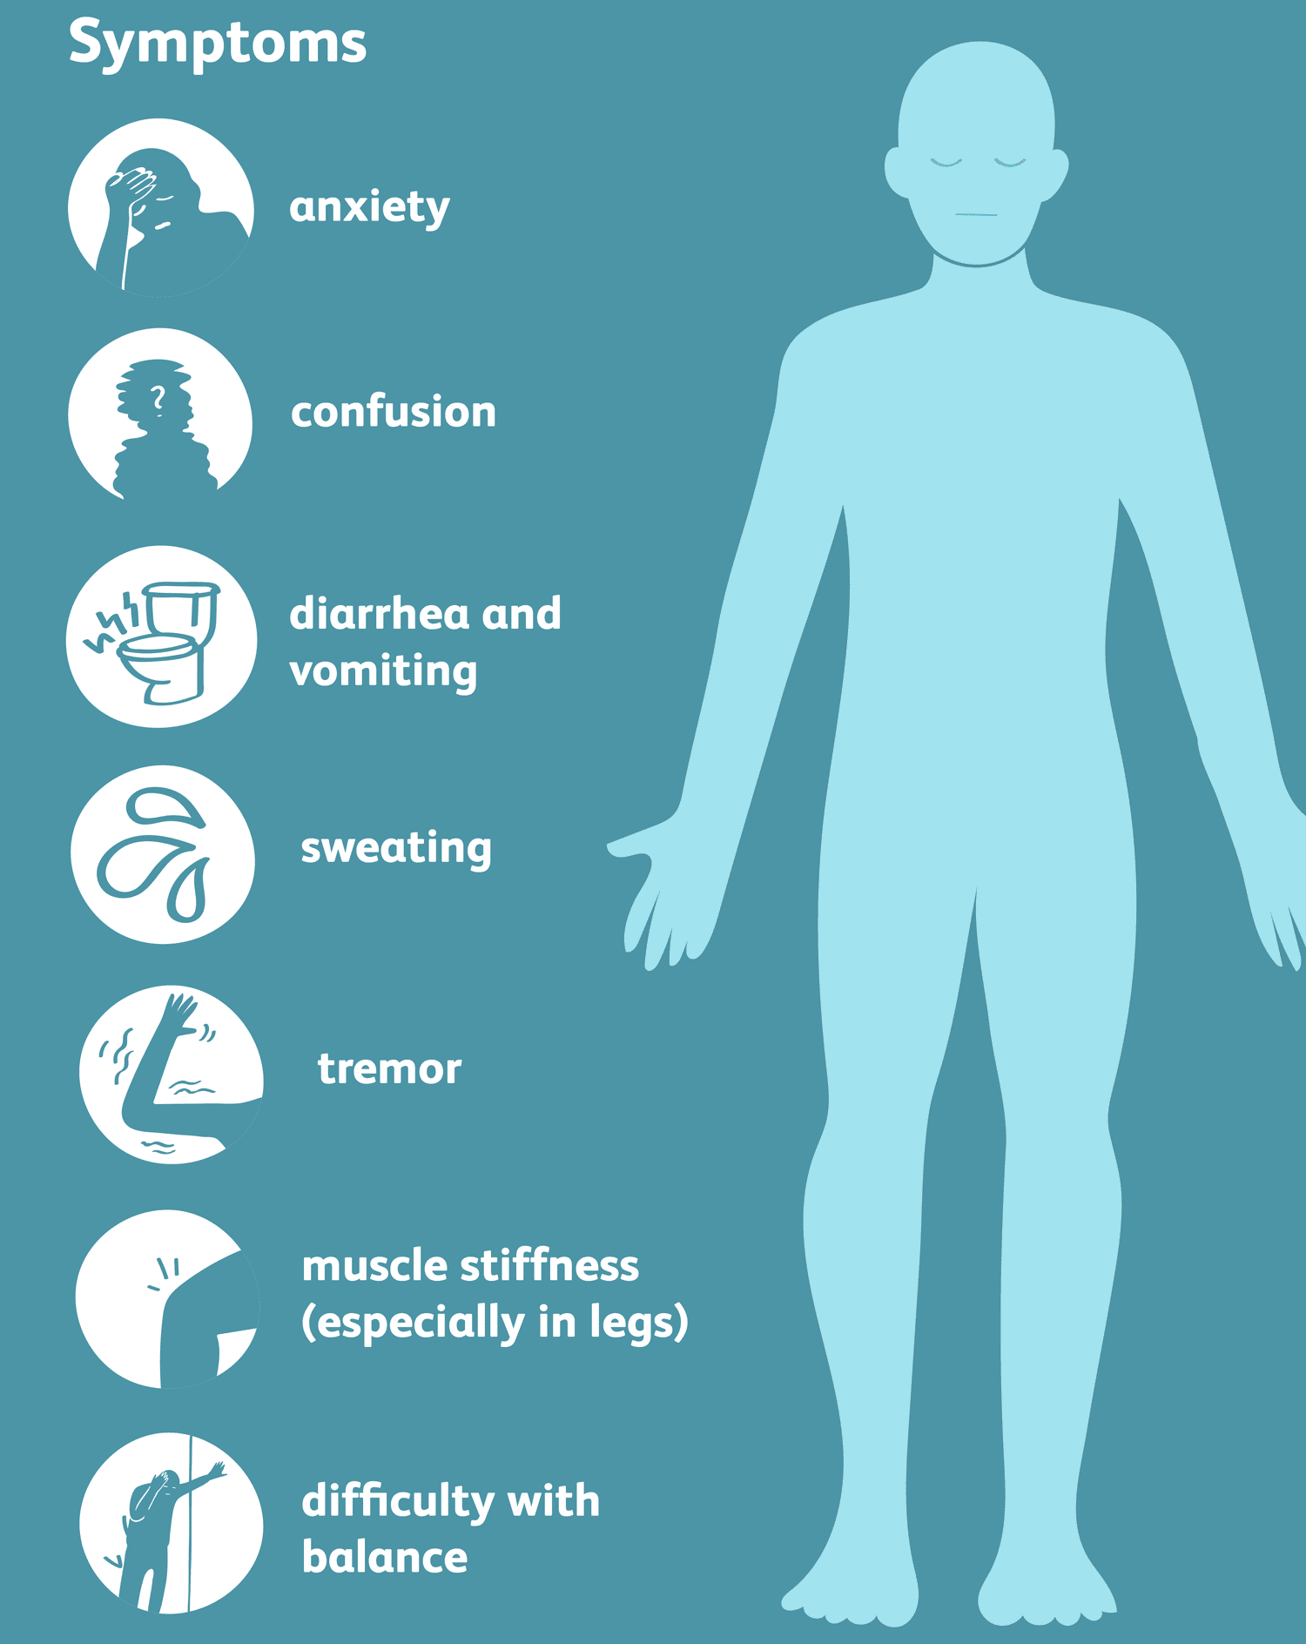
Too much serotonin causes extreme nerve cell activity and symptoms.

Symptoms of serotonin syndrome:
- confusion, agitation, restlessness
- dilated pupils, headache, high blood pressure, rapid heart rate
- nausea, vomiting, diarrhea
- tremor, twitching or rigid muscles
- shivering and/or heavy sweating

Severe cases can be life threatening. Signs include: high fever, seizures, irregular heartbeat, loss of consciousness, and death.

Causes:
- Caused by certain medications alone or in combination with others.
- Medications known to contribute to serotonin syndrome include:

Antidepressants especially SSRIs and SNRIs but also bupropion, tricyclic antidepressants, and MAOIs.

Antimigraine medications, pain medications, cough and cold medications and antinausea medications.

antipsychotic agents

Used since the 1950s to treat psychosis and manage chronic psychotic disorders such as schizophrenia and psychotic symptoms occurring in other disorders such as mood disorders. They are also used in the treatment of bipolar disorder and for augmentation in major depression.

First generation antipsychotics (neuroleptics) include:
- Haloperidol (Haldol®) ▪ Thioridazine (Mellaril®)
- Fluphenazine (Prolixin®) ▪ Thiothixene (Navane®)
- Chlorpromazine (Thorazine®) ▪ Perphenazine (Trilafon®)

Can cause extrapyramidal side effects and tardive dyskinesia.

Other side effects include:
- Increased prolactin levels which cause enlargement of breasts and production of breast milk (lactation) in both men and women.
- They can affect menstruation in females and cause decreased libido, impotence, and infertility in men.
- Weight gain, sedation, blunting of affect, anticholinergic effects
- Cardiac rhythm problems, lowered seizure threshold
- Neuroleptic malignant syndrome.

Second generation antipsychotics (atypical antipsychotics):

Lower risk for extrapyramidal side effects and tardive dyskinesia than with first generation antipsychotics but these risks vary depending on the dose and which medication is prescribed.

Side effects include:
- Increased risk for developing metabolic syndrome by affecting metabolic parameters including weight gain, high blood sugar levels, high cholesterol levels and hypertension.
- Lowering of the seizure threshold, increased prolactin levels, and cardiac rhythm abnormalities.

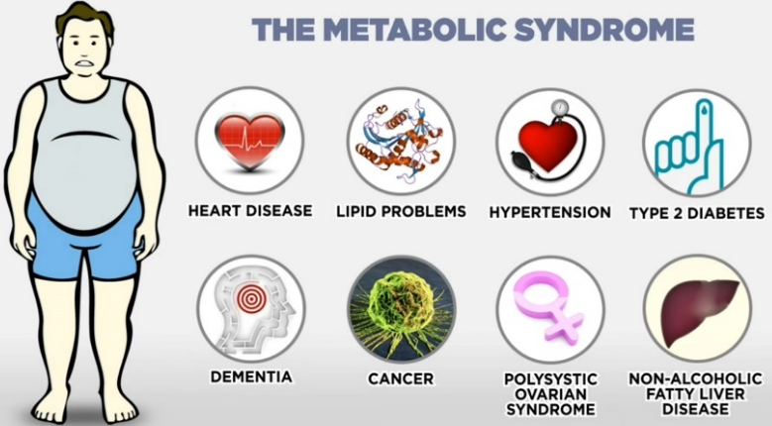
Include: aripiprazole, olanzapine, risperidone, paliperidone, clozapine.

Clozapine (Clozaril®): an antipsychotic that is different from the others.
- It can cause dangerously low white blood cell counts (WBCs).

Counts must be monitored carefully and frequently.

WBC must be within certain parameters in order to obtain the drug.

If Clozaril® is missed for two days, the dose must go back down and weekly counts will start over.
- Other side effects include:

Severe constipation and ileus (inability of intestine to contract normally thus affecting normal peristalsis)

Seizures

Low blood pressure

Tachycardia

Dry mouth

Myocarditis (an inflammation of heart muscle)

Neuroleptic malignant syndrome

Neuroleptic Malignant Syndrome (NMS):

NMS is a life-threatening neurologic emergency associated with the use of antipsychotic agents and other medications including anti-nausea medications, tricyclic antidepressants, lithium, and some medications used in Parkinson’s Disease.

Symptoms include:

Mental status changes – often agitated or hypoactive delirium

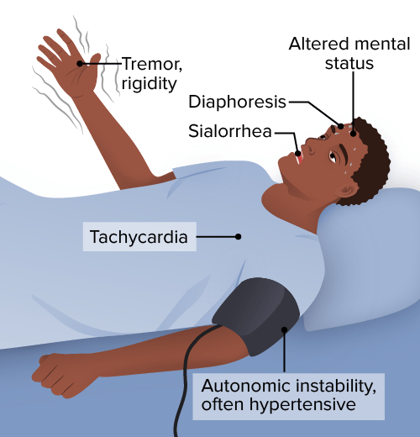
Muscle rigidity – generalized as “lead pipe” in nature

Temperatures over 110.4 degrees F

Elevated blood pressure, heart rate, and breathing

Cardiac rhythm problems

Sweating, pallor, excessive salivation

https://app.lecturio.com/#/article/3275

Extrapyramidal side effects (EPS)

Antipsychotics interfere with dopamine transmission thereby producing symptoms similar to those seen in Parkinson’s disease.
EPS Associated with Psychotropic Medications:
Side Effect (SE) | Signs/Symptoms | When SE Appears
Acute dyskinesia  (uncontrolled  muscle  movements) | - Blinking  - Writhing limbs  - Protruding tongue  - Uncontrolled movements of face (tics) and grimaces | Usually within 1 to 5 days of starting the medication
Akathisia  (severe  restlessness) | - Pacing, inability to hold still  - Rocking, foot tapping  - Restless legs  - Complaints of “jitters”, “crawling out of my skin” | Usually within 5 to 60 days of starting medication
Dystonia  (distorted movements of body, sustained muscle contractions) | - Lock jaw, contorted face  - Eyes rolled up  - Head snapped back or to side  - Rigidity, back arching | Usually within 5 to 30 days of starting medication
Pseudo-Parkinsonism  (mimic Parkinson’s disease) | - Tremor (unintentional, rhythmic)  - Slow movement (bradykinesia) or no movement  - Drooling, dysphagia, lack of expression, decreased blinking  - Pill rolling, cogwheel rigidity  - Shuffling gait | Usually within 5 to 30 days of starting medication
“Rabbit Syndrome”  (mimics chewing motions of a rabbit) | - Lip tremor  - Perioral (around the mouth) tremor | Can occur early in treatment or later
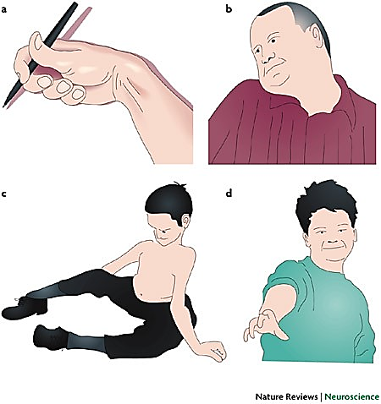
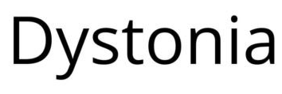
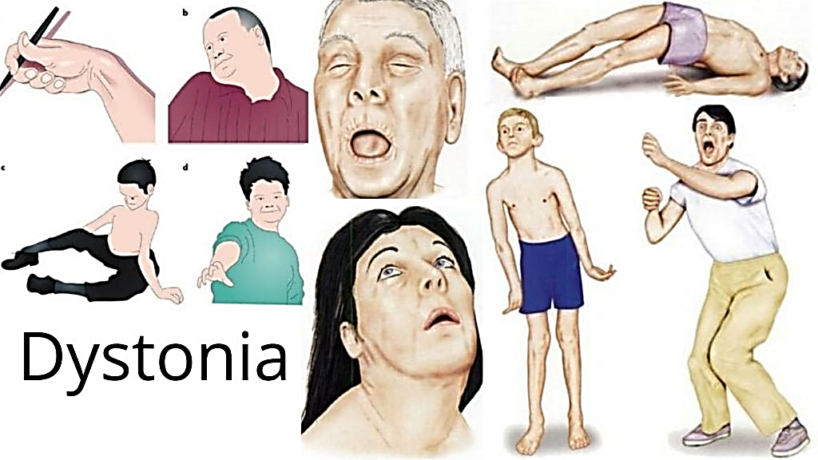
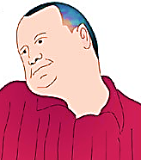
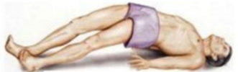

Tardive Dyskinesia (TD)

TD is a movement disorder caused by antipsychotic medications. Technically, the word tardive means delayed; dyskinesia means abnormal movement.

The risk increases with age, time of exposure to the medication, and prior development of EPS.

There are medications that can treat this disorder.

Symptoms are often mild but can be progressive and may become disfiguring or disabling.

TD causes stereotypical movements that can affect the lips, jaw, eyes, tongue, torso, upper limbs, and lower limbs.

Despite stopping the medication, they may never resolve.

These stereotypical movements are repetitive, rhythmic, non-purposeful movements that include:
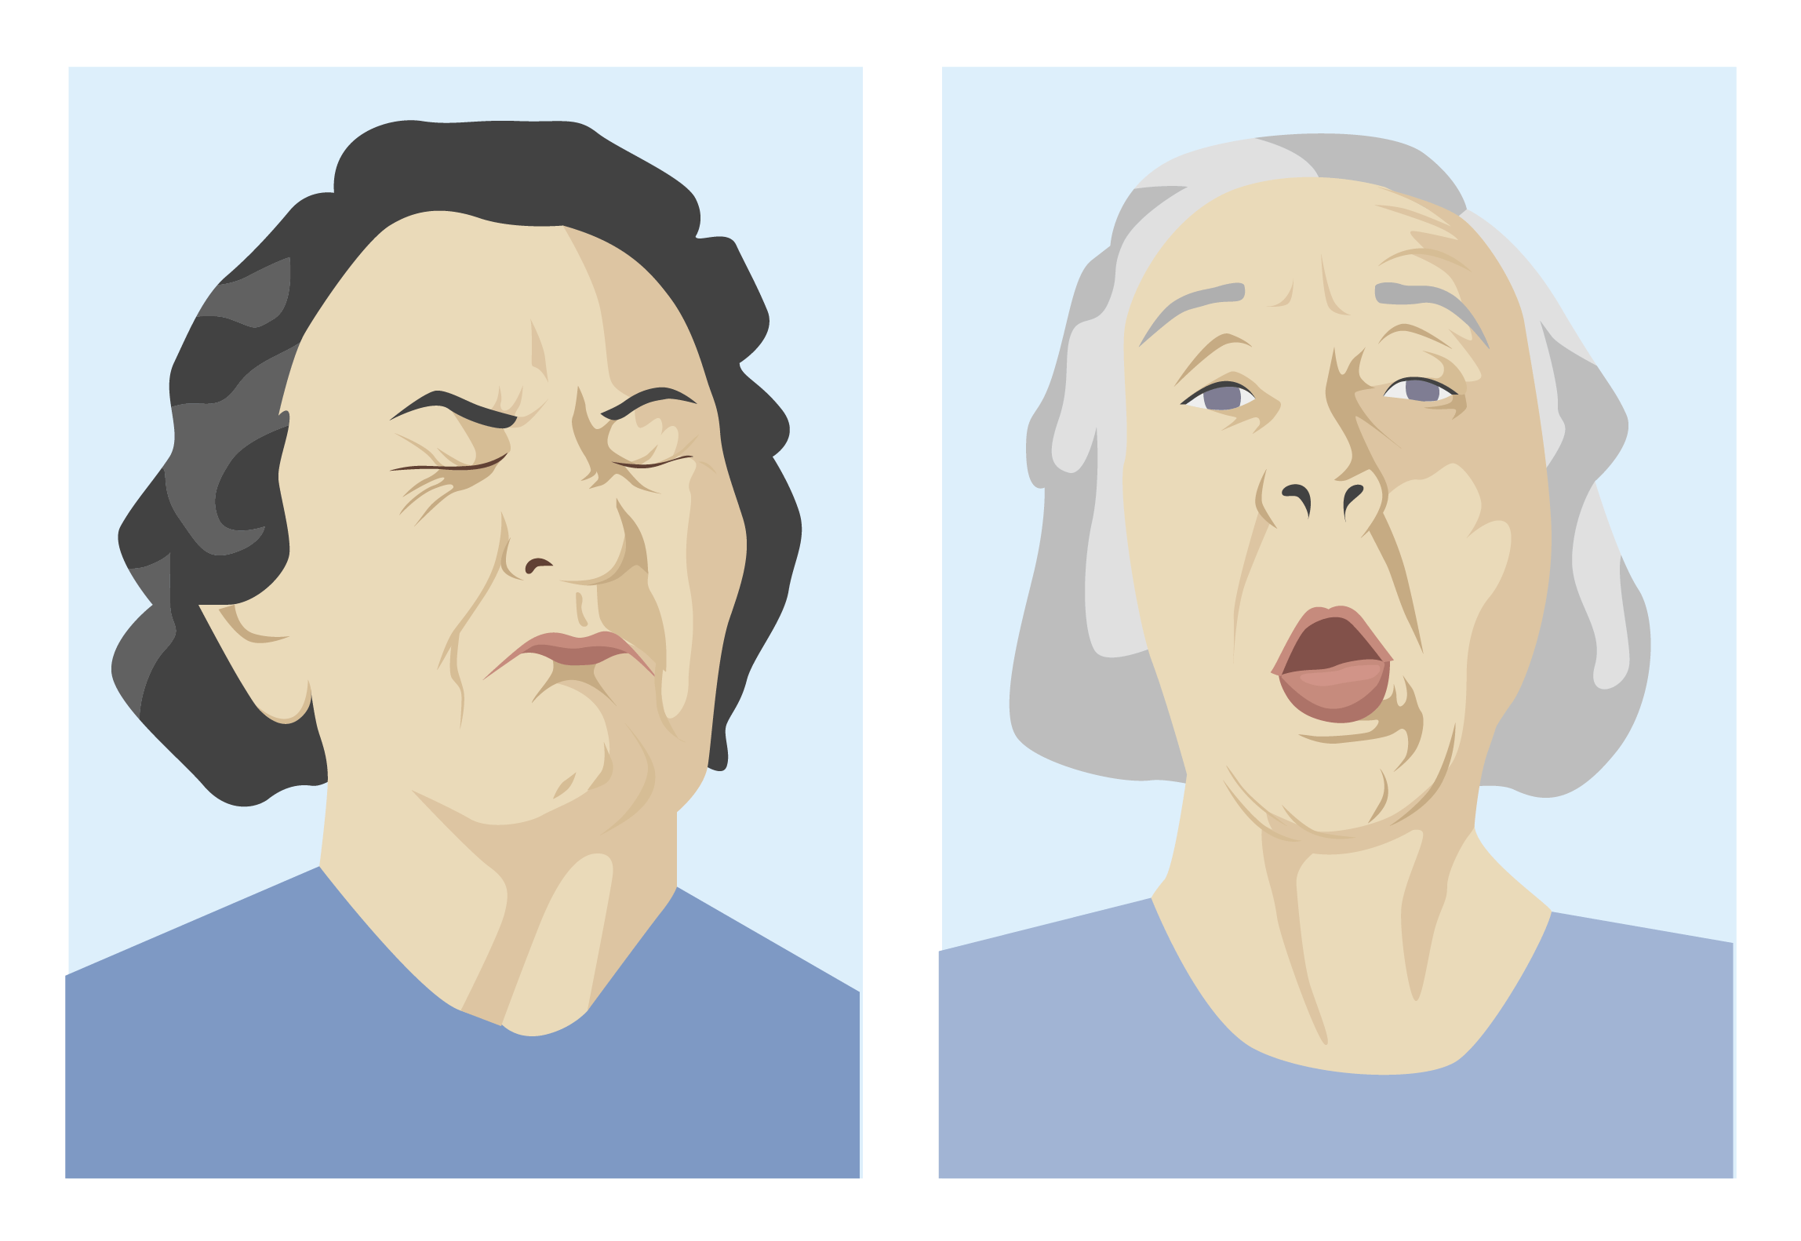
- Protruding, twisting of tongue
- Smacking lips, bulging cheeks, chewing movements
- Shoulder shrugging, thrusting of hips
- Rocking and swaying
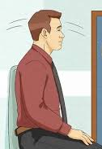
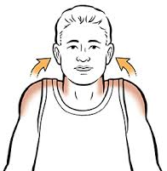

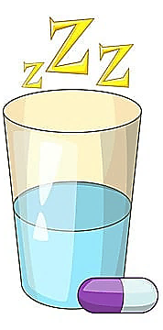
anxiolytics and hypnotics

Hypnotics, also known as sedatives or “sleeping pills”.

Are used to promote sleep and to help calm someone.

Can cause dizziness and lead to falls.

After being taken regularly, they often lose effectiveness and tolerance develops. Tolerance is a problem which pngtree.com

means it takes more and more to get the desired effect.


Anxiolytics are anti-anxiety drugs.

Antidepressants such as SSRIs are often prescribed to treat anxiety.

Beta-blockers are also prescribed for anxiety as they treat the physical symptoms of anxiety, including increased heart rate, nausea, sweating and trembling.

Benzodiazepines are a commonly used anti-anxiety drug. They are also used to treat seizures and as muscle relaxants.

They work quickly and can be taken when needed.

They have the potential for abuse.

If used on a regular basis, abrupt stopping of benzodiazepines can cause withdrawal symptoms which include:
- elevated body temperature, blood pressure, heart rate, and respiratory rate
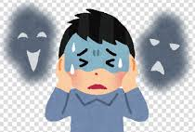
- tremulousness
- disorientation or delirium
- psychotic behavior
- hallucinations
- seizures

Cannabidiol

Cannabidiol (CBD), unlike THC, can be used to treat anxiety.

Hemp-derived CBD products with less than 0.3% THC are federally legal.

Side effects include dry mouth, diarrhea, reduced appetite, drowsiness, and fatigue. It can also interact with other medications.

THC can cause or increase anxiety.


mood stabilizers

Mood stabilizers are medications that help regulate extreme emotion. They treat and prevents highs (mania) and lows (depression) and help keep moods in balance in Bipolar Disorder.

Lithium was the 1st mood stabilizer discovered; it was used to control mania.

Other mood stabilizers

Atypical antipsychotics have mood stabilizing activity.

Anticonvulsants are also used as mood stabilizers, including:
- Carbamazepine (Tegretol®) ▪ Oxcarbazepine (Trileptal®)
- Valproic acid (Depakote®) ▪ Lamotrigine (Lamictal®)
- Topiramate (Topamax®) ▪ Gabapentin (Neurontin®)
- Pregabalin (Lyrica®)

Stimulants

Often given to people with attention deficit hyperactivity disorder (ADHD) to help manage unorganized behavior.

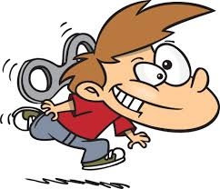
They stimulate the central nervous system to increase the ability to focus, increase arousal and endurance, and may elevate mood

They can be addictive.

Side effects include increased heart rate, elevated blood pressure, sleep problems, decreased appetite, weight loss.

Stimulants include:
- Methylphenidate: Ritalin®, Concerta®
- Amphetamine mixed salts: Adderall®
- Lisdexamfetamine: Vyvanse®

Non-stimulant medications used to treat ADHD include:
- Strattera® an SNRI.
- Antihypertensives such as guanfacine (Tenex®) and clonidine (Catapres®).

See Appendix 10. MEDICATIONS FOR PSYCHIATRIC CONDITIONS for more information.

Chapter 11. SEIZURE DISORDERS

A seizure is a sudden, uncontrolled electrical disturbance in the brain. Epilepsy is the tendency to have recurrent nonprovoked seizures. The brain contains billions of neurons (nerve cells) that create and receive electrical impulses. Electrical impulses allow nerve cells to communicate with one another. During a seizure, there is abnormal or excessive electrical activity in the brain which can cause changes in awareness, behavior and/or abnormal movements. This activity usually lasts only a few seconds to minutes.
The word epilepsy is derived from the Greek word epilepsia meaning to seize or attack. Seizures and epilepsy are common disorders and have been documented since the earliest recordings of humans. Not everyone who has a seizure has epilepsy. A single seizure may be provoked by drugs, toxicity, or imbalances in the body. Nonepileptic seizures can be caused by other conditions.

seizures

Nonepileptic seizures:

Look like seizures, however they are not caused by abnormal brain activity.

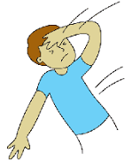
Causes:
- Syncope (fainting spells).
- Anxiety and other psychological disorders.
- Sleep disorders.
- Movement disorders (spasms).
- Migraines.
- Transient ischemic attack (TIA).

Provoked seizures:

Occur because of some abnormality or imbalance in the body.

Once the abnormality is corrected, the seizure will no longer occur.

Causes:
- Low or very high blood sugars, very low calcium levels.
- A fall in blood sodium level that occurs quickly.
- Kidney failure, hyperthyroidism (over-active thyroid).
- Anoxia (low oxygen levels) due to heart problems, respiratory arrest, carbon monoxide poisoning, drowning, etc.
- Drug toxicity (for example a Dilantin® level
that is too high).
- Drug withdrawal states (especially alcohol or benzodiazepines).


Photic-induced seizures:

Photosensitivity (increased sensitivity to bright light) can trigger seizures.

The light may come from natural or artificial sources.

Children are more susceptible than adults, females more than males.

Seizures are usually generalized but may be focal.

CAUSES OF SEIZURES OR EPILEPSY

Genetic influence and developmental conditions.

Head trauma or injury before birth such as infection in mother.

Brain tumors or other malformations, strokes.

Infections.

influencing factors
Lifestyles can influence or trigger seizure activity. Factors include:

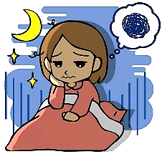
Missing medications.

Lack of sleep – seizures are sensitive to sleep patterns. Lack of sleep changes the brain’s electrical and hormonal activity.

Stress.

Alcohol.

Drug abuse.

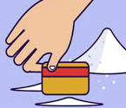
Cocaine use can cause seizures within seconds to hours. These seizures can be associated with heart attacks and cause death.

Amphetamines and other stimulants can cause sleep deprivation, confusion, and psychiatric disorders which

may increase seizures or may make missing medications more likely and thus increase seizures.

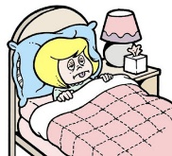
Heroin and related narcotics do not directly affect the likelihood of seizures but often cause people to forget to take their medications.

Illnesses

Being sick with a cold, or a sinus or lung infection, etc. can increase seizure activity. This is usually due to the stress of the illness, having a fever, getting dehydrated, and/or not sleeping well. Thus, it is important to never skip medications when ill.

OTC medications:

Diphenhydramine, an antihistamine found in medications for colds, allergies, and for sleep, can affect seizures.

Some herbal medications have ingredients that can either increase the chance of a seizure or affect seizure medications.

Some OTC medications affect the blood level of seizure medications.

Diet:


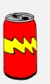

Stimulants such as tea, coffee, chocolate, sugar, sweets, soft drinks, excess salt, spices, and animal proteins may trigger seizures by suddenly changing the body’s metabolism.


Caffeine in high doses affects sleep, thus affecting seizure

activity. Energy drinks are very high in both caffeine and sugar.

Allergic reactions to certain foods can trigger seizures.

Visual stimuli:


Any light that has a flickering, flashing, or strobing effect can trigger seizure activity:
- Flash of a camera.
- Flashing video games or television screens.
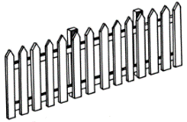
- Automobile headlights.
- Certain visual patterns such as stripes, walking by a picket fence, etc.

- Direct sunlight or patterns of light shining through tree branches, curtains, etc.
- Rotating blades of a helicopter or ceiling fan.
- Reflections from water or snow.

Hearing:


Hearing many different noises at once.

A sudden occurrence of a loud noise.

Specific patterns in songs or nursery rhymes.

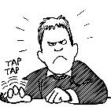
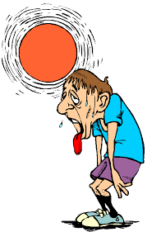
Movement:

Sudden movement.

Tapping or repetitive motions.

Other:

Hyperventilation.

Fever.

Extreme temperatures or sudden drastic changes in temperature.

TYPES OF SEIZURES
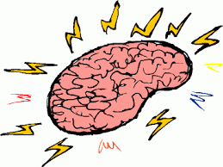
Seizures are classified based on the appearance of the seizure and part(s) of the brain involved in the seizure. There are three main types of seizures: focal onset, generalized onset, and unknown onset. Steps in classification include:

Is the seizure focal or generalized in onset or is this unknown?

If the seizure is focal, is the person fully aware during the seizure?

Generalized seizures are broken down into motor or nonmotor.

The terms: simple partial, complex partial, and secondarily generalized have been eliminated.
You should have some basic knowledge of seizure types, but your job is not to diagnose seizure types. Your job is to observe what occurred before, during, and after a seizure and then describe what occurred. This information should be recorded so that it can be reviewed by the medical provider.

Focal seizures:

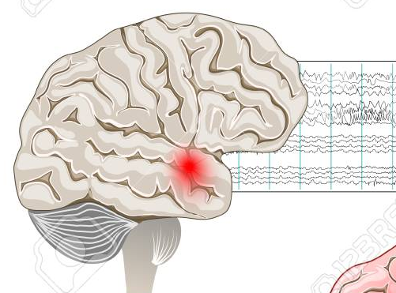
The term “focal” has replaced “partial” to describe these types of seizures.
- Focal seizures are the most common type.
- Focal seizures originate or start in one area of the brain.
- They can become generalized and spread to other areas. www.123rf.com/photo_110101258_epilepsy

Focal seizures are typically broken down into four areas depending on the location in the brain and parts of the body affected.
- Motor: affects muscle activity, causing jerking movements of the foot, face, arm, or another part of the body.
- Sensory: can cause symptoms affecting the senses such as hearing, hallucinations, and olfactory or other distortions.
- Autonomic: affects the part of the brain responsible for involuntary functions.
- Psychic: seizures that strike parts of the brain that trigger emotions or memories of previous experiences, causing feelings of fear, anxiety, or déjà vu.

Symptoms:
- Focal motor: some type of movement occurs such as twitching, stiffening, or automatisms.
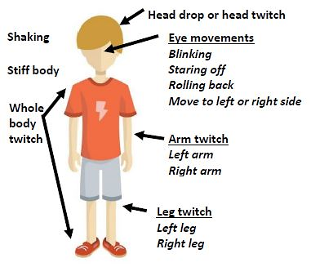

- Focal sensory:

Auditory: hearing sounds such as buzzing, ringing, drumming.

Gustatory: acidic, bitter, salty, sweet, or metallic tastes.

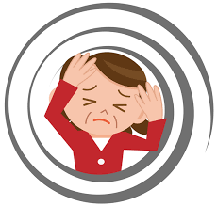
Hot or cold sensations.

Olfactory: smelling an unpleasant odor.

Somatosensory: tingling, numbness, pain, sense of moving, or desire to move.

Vestibular: dizziness, spinning or sense of rotation.

Visual: seeing flashing or flickering lights, colors, shapes, patterns, etc.
- Focal autonomic:

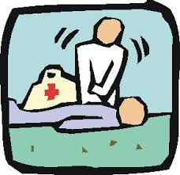
Cardiac arrest

Slow or fast heart rate.

Palpitations: rapid, strong, or irregular heartbeat.

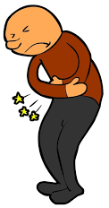
Hyperventilation (breathing fast), hypoventilation (breathing slow), or altered breathing.

Gastrointestinal: sensations of stomach discomfort, tightness, churning, hunger, nausea, vomiting.

Paleness or flushing.

Piloerection: hairs of the skin stand on end.

- Focal psychic:

Cognitive:
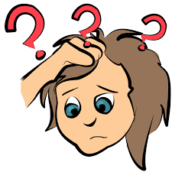
- Aphasia: loss of ability to understand or express speech.
- Dysphasia: difficulty expressing speech.
- Déjà vu: feeling of having lived through a situation before.
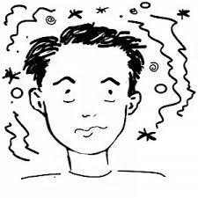
- Dissociation: disconnected.
- Memory impairment: cannot remember events during the seizure.
- Hallucination or illusions: alteration of senses (hearing or vision).
- Neglect: unable to respond to one side of the body.

Emotional:
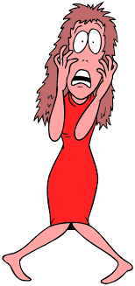

- Agitation, anger: may be accompanied by aggressive behavior, usually seen during the post-ictal period.
- Fear, anxiety, paranoia: crying not related to feeling sad.
- Laughing, giggling: not related to feeling happy.
- Pleasure, joy, bliss.

Seizure auras:

An aura is a subjective experience felt by the person having a seizure:
- May be sensory, emotional, autonomic, or cognitive.
- Reflects the initial seizure discharge in the brain.
- Can be an isolated phenomenon or progress to a focal seizure.
- Often referred to as a warning that a seizure will occur.
Examples of Auras
- Nausea
- Dizziness
- Headache
- Difficulty with speech or breathing
- Numbness of hands, lips, tongue
- Unpleasant taste or smell
- Visions
- Hearing things
- Palpitations

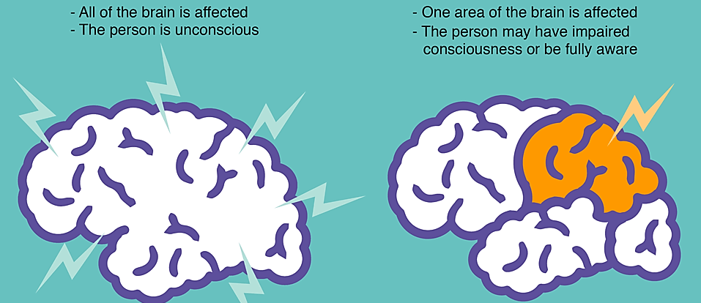
Generalized Seizures Focal Seizures
youngepilepsy.org.uk/

Generalized seizures:

Start on both sides of the brain.

Can be motor or non-motor (absence).

Are no longer called: “grand mal”.

The term “generalized tonic-clonic seizure” is still used to describe seizures that have stiffening (tonic) and jerking (clonic) of limbs.

Awareness is almost always impaired.
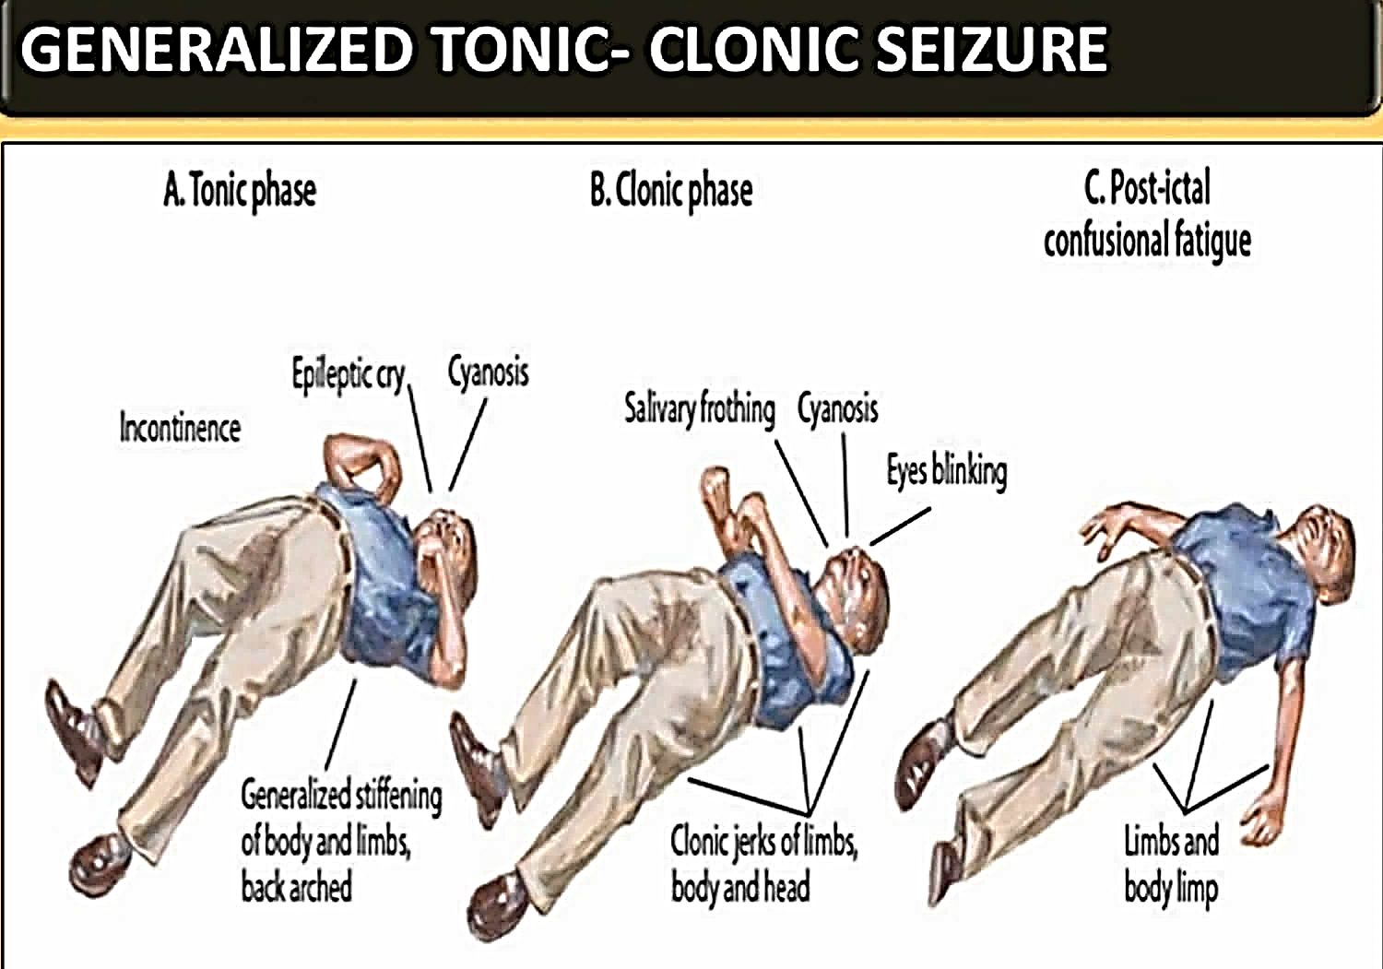
Tonic phase Clonic phase Post-ictal phase

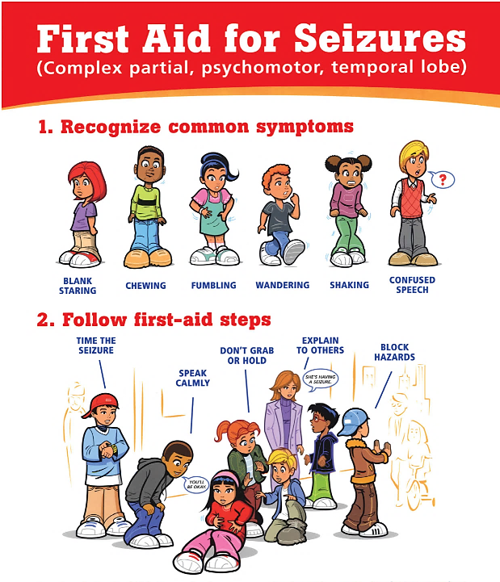
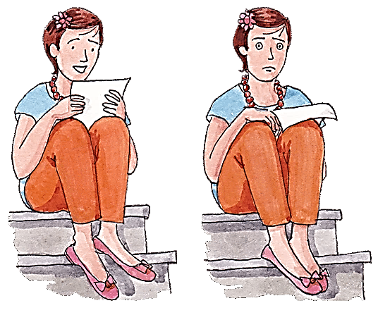
Absence Seizure Focal Seizures
The difference between absence and focal seizures:
- The term “absence seizures” corresponds to the old term “petit mal”.
- No aura occurs with an absence seizure.
- Absence seizures cause lapses in awareness, sometimes with staring.
- An absence seizure begins in both sides of the brain.
- Absence seizures begin and end abruptly, lasting only a few seconds.

netclipart.com, https://santripty.com/ www.epilepsynorcal.org/seizure-first-aid/

first aid for seizures
When someone has a seizure, it is your job to keep them safe.

Steps to take when someone has a seizure:

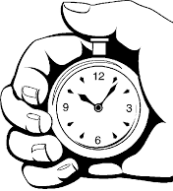
Note the time – document how long the seizure lasts. If a watch or something with which to note the time is not available, try to do so as soon as a watch, or or another timepiece is available.

If not already on the floor, help the person to the floor to prevent injury.

If secure in a bed or in a wheelchair, the person can remain there if there is no chance of falling out of the bed or wheelchair.

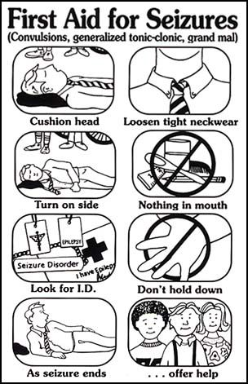
Be sure nothing is tight around the person’s neck.

Turn the person on their side if lying flat. This prevents choking or aspiration from saliva or vomit.

Cushion the head with a small pillow or rolled up garment; remove eyewear.

Clear the surrounding area of anything that is

sharp, hard, or hot to prevent injury.

Follow protocols for the use of a VNS magnet or PRN

medications.

Stay with the person and offer comfort, reassurance, and whatever assistance is needed after the seizure is over. Make sure the person is alert and feels comfortable before leaving him/her alone. Check on the person frequently.

DO NOT:
- Do not restrain the person
- Do not force anything between the teeth.

Despite the myth, it is nearly impossible for a person to swallow their own tongue.
Do not move the person unless he/she is in danger or near something hazardous or in water.
First Aid for Seizures images obtained from https://choosehealth.utah.gov/

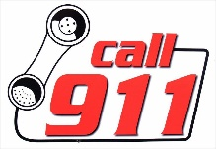
Call 911 if:
- The person stops breathing.
- This is the first seizure the person has ever had.
- The person sustains an injury during the seizure.
- The person remains unconscious after the seizure ends.
- The person has not had a seizure in 12 months or more.
- The seizure is different from the person’s typical seizure.

Special Circumstances:

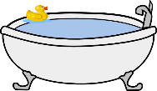
A seizure in water:
- Support the person’s head so face stays above water to make sure no aspiration occurs.
- Get person out of the water as quickly as possible.
- Once on a surface, if the person is not breathing, begin CPR.
- Call 911 or transport person to the emergency department for further evaluation once the seizure has stopped.

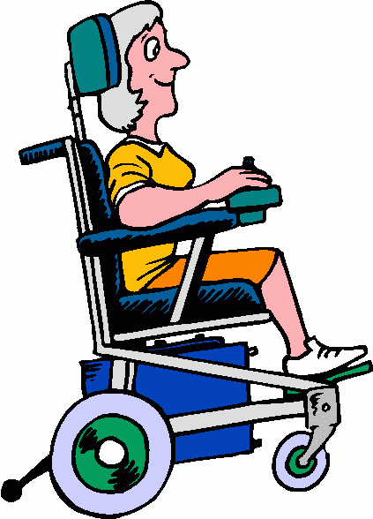
A seizure in a wheelchair:
- Check to see if the person is secured. If so, there is no need to transfer to the floor. If not secured, move to the floor to prevent a fall from the chair.
- Make sure that any hard surfaces are padded by placing rolled up clothing or cushions between them
and the person.

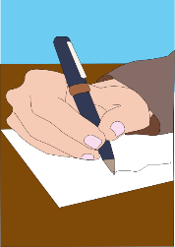
documentation
You will need to accurately document any seizure witnessed.

When: record date, place, time of day of the seizure.

Before: record any unusual behavior, sensations or feelings

the person may have shown or mentioned prior to onset.

Mention any contributing factors such as missed

medications, illness, change in diet, or lack of sleep.

During: record the sequence of behavior during the seizure:

How did it start? Did breathing stop; did the skin turn blue or gray?

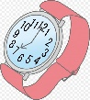
Describe what you saw. Were muscles tensed, jerking, etc.?

Did the person fall or lose bladder or bowel control?

Duration: record the duration or length of the seizure.

After: record what occurs just after the seizure:

When did the person become fully aware?

Did the person complain of anything such as a headache?

Was the person drowsy, confused, agitated, etc.?

Did any injuries occur?

Did the person report an aura? Could the person remember anything that occurred prior to the seizure?

treatment

Anti-seizure medications (anticonvulsants) – general guidelines:

Anticonvulsants must be taken regularly even if not having seizures.

Missing doses or stopping a medication can cause seizures to occur.

More than one anti-seizure medication may be necessary for control.

Some medications require monitoring of drug levels or other tests as antiseizure medications can cause:
- Low sodium levels (hyponatremia).
- Low white blood cell counts and anemia.
- Liver problems, elevated ammonia levels.

Specific issues related to anti-seizure medications:

Lamotrigine (Lamictal®)
- Lamotrigine can cause serious rashes requiring hospitalization and even death.
- These occur infrequently, usually within the first 2 to 8 weeks of treatment but require special attention.
- There is an increased risk for rashes:

With high doses or increasing the dose too quickly.

With combining lamotrigine with Depakote®.
- Any rash that occurs must be checked by a medical provider.

Elevated ammonia levels:
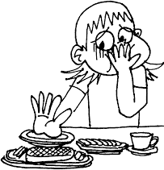
- Sometimes seen in people taking anti-seizure medications especially Depakote®, but also seen with phenytoin, phenobarbital, topiramate and zonisamide.
- May not observe symptoms if only mildly elevated.
- Symptoms may come and go and include:


Nausea, loss of appetite.

Pain in back, sides, abdomen.

Muscle weakness, fatigue, confusion.

Ataxia or gait abnormalities.
- Symptoms may progress when levels go higher causing:

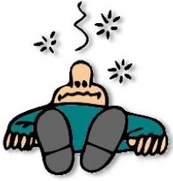
Decreased or absent urine output.

Changes in mood, behavior, personality.

Change in alertness, level of consciousness.

Seizures, passing out, unresponsiveness.

Sudden and/or severe confusion.
- Other conditions can cause high ammonia levels including:

Liver and kidney disease, GI bleeding.

Severe dehydration.


Cannabidiol:
- Research is being done using cannabidiol to treat seizures. No formal studies show that medical marijuana, or any form of natural CBD, has any efficacy for seizure treatment.
- Epidiolex® (a pharmacologic solution containing a specific amount of cannabidiol) is approved for treating Dravet Syndrome, Lennox-Gastaut Syndrome, and tuberous sclerosis complex.

Epidiolex® has several side effects and anyone taking it must be monitored for liver damage.
- Side effects of cannabidiol include:

anorexia, not feeling well

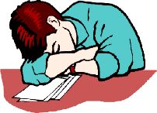
anemia


diarrhea

rash

elevated liver tests

drowsiness, sedation, lethargy

insomnia

Nonpharmacologic and other therapies:

Vagus nerve stimulators:
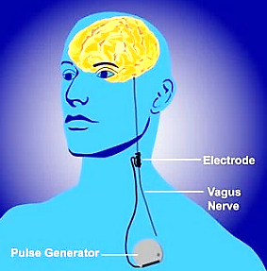
- Similar to cardiac pacemakers, a VNS unit is placed under the skin of the upper left chest. Electrodes then stimulate the vagus nerve.
- A standard, baseline stimulation is set and can be adjusted as needed. This can prevent or lessen seizure activity.
- The device is activated with a magnet that is passed by it when someone is having an aura or other scientiaportal.wordpress.com/ seizure activity. This stops the seizure activity.
- Side effects include:

throat pain, hoarseness, coughing

shortness of breath

tingling, muscle pain

Surgical treatment:
- Surgically removing a part of the brain where the seizure originates.

Ketogenic diet:
- A specific high-fat, moderate protein, low carbohydrate diet that produces metabolic changes and has been effective in children with drug resistant epilepsy. It is generally not tolerated long term.

status epilepticus
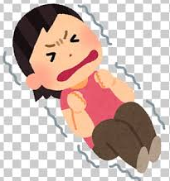
Prolonged generalized seizures or clusters of shorter seizures can lead to status epilepticus.

Prolonged seizures must be treated quickly to prevent death.

Medications that medication certified staff can give are ones that can be absorbed quickly through the mouth, nasal, or rectal mucosa.

Protocols for treating seizures or clusters of seizures must be in place for someone with a seizure disorder

Benzodiazepines are the first line treatment:

Lorazepam (Ativan®)
- Available as Lorazepam Intensol® (a concentrated oral solution) and tablets.
- Can be given by the buccal route (inside the lower lip) but this route takes longer to work.
- Can be given by the intranasal route.

Midazolam (Versed®)
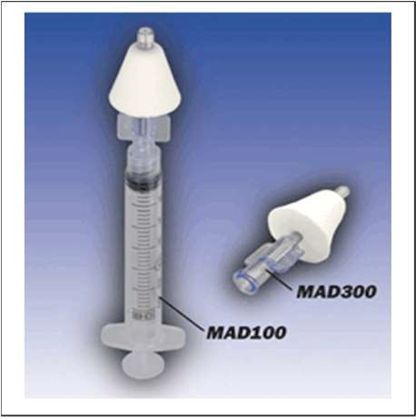
- Often given via the intranasal route but can be given by the buccal route.
- Works faster than rectal diazepam.
- Used in hospitals where it is given IV or IM.
- Can be obtained in a prefilled device for giving via the intranasal route (Nayzilam®) or drawn into a syringe and given via
a specific atomizer attached to the syringe.

Diazepam (Valium®) Ohio DDD med manual
- Diastat® is a rectal gel given with a syringe into the rectum. This is more difficult to give than a nasal spray.
- Diazepam is also available in a nasal spray (Valtoco®)

See Appendix 11. SEIZURE DISORDERS for more information.

Chapter 12. STROKES AND TIAs

TIA (TRANSIENT ISCHEMIC ATTACK)

Temporary (transient) periods when the brain doesn’t work correctly.

Begin suddenly, then resolve rapidly and completely within 24 hours.

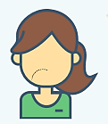
Caused by temporary lack of blood supply to brain.

Referred to as “warning signs” for having a stroke.

Symptoms: (same as for a stroke)

Hand, face, arm, or leg weakness or numbness.

Difficulty speaking, slurred speech, or inability to speak.

Blurred, double, or decreased vision in one or both eyes.

Loss of balance, dizziness.

stroke

Injury to the brain from loss of blood supply and thus loss of oxygen (ischemia). This causes brain tissue to die.

Two main types:

Ischemic (from blockage of blood vessels), and

Hemorrhagic (from bleeding in the brain).

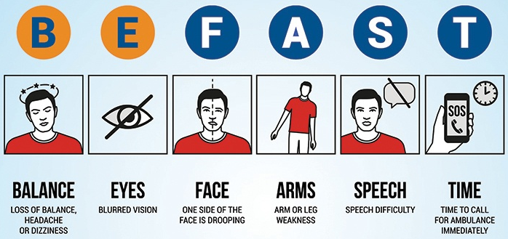Signs of a Stroke

Risk factors for stroke and tia
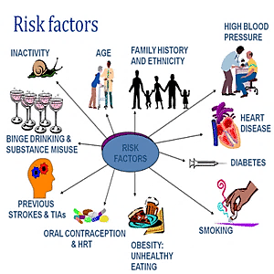
See Appendix 12. Strokes for more information.

All clipart in Section 1, except where indicated, were obtained from clipart-library.com

