ManTech International
Corporate Travel Card Application

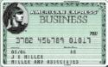 Check to select AMEX 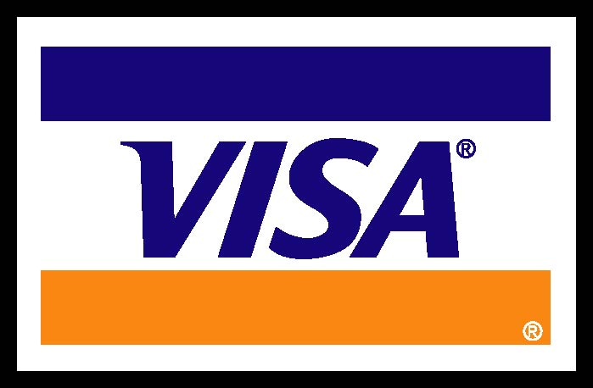 Check to select VISA

Application Information - Application cannot be processed without required information.
NAME as you would like it to appear on the Corporate Card (20 characters maximum, including spaces.)
BILLING ADDRESS
Street Address |  |  |  |  |  | Home | Office
City |  |  | State |  | Zip Code
HOME ADDRESS
Street Address (if different than billing address)
City |  |  | State |  | Zip Code
Social Security Number | Employee Birth Date (MM/DD/YYYY)
Business Phone Number | Home/Personal Phone Number
Employee ID Number | Employee E-mail Address
X
Employee’s Signature Date

Please read the Agreement before signing. By signing above I indicate my acceptance of the terms and conditions of the Agreement.
Program Administrator - Application cannot be processed without required information.
MTISC | LYNN SMITH - CTCP Field Rep
MTISC | BCA # 3782-790719-51002
MANTECH INTERNATIONAL INC.
Authorizing Signature - ManTech Corporate Travel Card Programs Administrator. Date
Stephanie M. Soriano, Program Administrator |  | Phone: 703-218-6421 Fax: 703-218-6441
All applications require the Program Administrators Authorization.

