BEFORE THE SUPREME COURT OF INDIA

Writ Petition No. /24 (PIL)

(Original Jurisdiction)

Between:

Society of safe Bharath …Petitioner

And:

Union of India and Others …Respondents

**AFFIDAVIT**

I, Dr. Banu Prakash A. S., son of Sh. R. Shankaraiah, aged 48 years, hold MBBS, MS (Bombay), MCh in Neurosurgery, PGIMER Observership in Barrow Neurological Institute of USA. I am a licensed neurosurgeon and spine surgeon residing in Bangalore. I hereby solemnly affirm and declare as follows:-

1. I am aware that the NGO, Society of Safe Bharath against Covert Torture and Energy Weapons, is filing a public interest litigation at the Supreme Court of India. I have been consulted by several victims of the NGO. Additionally, I have knowledge of neuromodulation developments and experience with various brain implants used in therapeutic interventions. Below, I provide some insights into recent developments.
2. The WISER Neuromodulation Program explores the clinical application of low-intensity electrical, magnetic, and ultrasonic energies to alleviate severe psychiatric symptoms and understand their neural mechanisms. These modalities are designed to improve deficient brain functions and aid in the reintegration of psychiatric patients by addressing persistent symptoms. Research has demonstrated that low-intensity electrical, magnetic, and ultrasonic energies can modulate brain plasticity, the brain's ability to adapt and change, and influence their underlying mechanisms. The WISER program receives support from the National Institute of Mental Health and Neuro Sciences (NIMHANS), Ministry of Science and Technology (Department of Science and Technology, Department of Biotechnology), India Alliance DBT Wellcome, and the Indian Council of Medical Research

Here are the brain stimulation techniques employed under the

WISER program:

* Electrical Techniques:

Transcranial Direct Current Stimulation (tDCS): Uses low-intensity direct current to modulate brain activity.

High Definition Transcranial Direct Current Stimulation (HD-tDCS): Refines tDCS by targeting specific brain areas.

Transcranial Alternating Current Stimulation (tACS): Applies alternating current to influence brain oscillations.

Transcranial Pulsed Current Stimulation (tPCS): Delivers pulsed current to modulate brain function.

Transcranial Random Noise Stimulation (tRNS): Applies random noise to enhance plasticity.

Galvanic Vestibular Stimulation (GVS): Stimulates the vestibular system.

Transcranial Vagal Nerve Stimulation (tVNS): Targets the vagus nerve.

* Magnetic Techniques:

Low Field Magnetic Stimulation (LFMS): Utilizes weak magnetic fields to modulate brain activity.

* Ultrasonic Technique:

Transcranial Pulsed Low-intensity, Low Frequency Focused Ultrasonic Stimulation: Applies focused ultrasonic waves to the brain. (Citation #2)

These methods hold promise for treating psychiatric disorders and improving brain plasticity. By exploring these innovative approaches, the WISER program aims to enhance mental health outcomes and promote well-being. (Citation #1)

1. A new neurostimulator, the wireless artifact-free neuromodulation device (WAND), can precisely deliver treatments to patients with diseases like Parkinson’s and epilepsy. this device functions as a pacemaker for the brain, monitoring electrical impulses of nerves while simultaneously delivering electrical impulses when abnormalities are detected. WAND is a groundbreaking device being that it is not only wireless but autonomous as well, meaning that it learns to recognize signals of seizures and tremors and self-adjusts electrical impulses to prevent unwarranted movements. As a closed-loop device that records and stimulates the brain in concert, WAND can adjust these parameters in real time. (Citation #2)

WAND:

|  |
| --- |
|  |

1. The National Institute of Mental Health & Neuro Sciences (NIMHANS), India's premier center for mental health and neuroscience education, has implemented **Dassault Systèmes’ SIMULIA** applications to forecast the effectiveness of Transcranial Direct Current Stimulation (tDCS), a non-invasive clinical therapy for schizophrenia patients, virtually prior to the clinical intervention. Utilizing Dassault Systèmes’ SIMULIA and **BIOVIA** applications on the 3DEXPERIENCE platform, brain models are generated to accurately predict the potential impact of electrical stimulation. This personalized approach enables tailored neuromodulation for treating symptoms of schizophrenia. Simulation technology plays a crucial role in anticipating challenges and predicting outcomes of treatment procedures for disorders like schizophrenia. (Citation #3)
2. i. iSenses-Incorporation, located in Jodhpur, India, is a machine intelligence company that offers the Drishti machine vision platform (Omnividence: to see all). Drishti is powered by a patented neural network algorithm inspired by the biological visual cortex, providing valuable insights with limited or partial training data on the edge. Our software analyzes data ensemble gathered from active-passive sensors across space, aerial, and terrestrial platforms, offering users real-time event analysis and situational awareness.

ii. At Origin Interconnect (ORIC) in New Delhi, India, we specialize in cutting-edge biosensor technology. Our focus lies in designing bioelectronics and biofeedback sensors for amplifying biopotential signals, enabling the development of human-computer interfaces with ease.

iii. HevaAI, based in Bangalore, India, specializes in diagnosing neurological disorders using artificial intelligence (AI). The company analyzes EEG data to diagnose conditions such as Alzheimer's, Parkinson's, schizophrenia, frontotemporal dementia, depression, or determine a healthy state.

iv. CerebralX, headquartered in Bangalore, India, is a neurobionics company dedicated to enhancing and restoring human efficiency. Our focus lies in developing systems to restore and enhance vision, auditory processing, physical ability, cognitive function, and speech.

v. DesignSyndromeExperience Lab LLP, located in Bangalore, India, specializes in human behavior analysis and prediction. Leveraging visual and color psychology, we document behavior on products within retail, service, and social spaces. Our expertise includes analyzing movements, pattern mapping, and predictive analysis. Combining deep neuroscience and ancient methodologies, we map user behavior and patterns both on digital platforms and local platforms. (Citation #4)

vi. Synchron, a leader in neural interface technology, is currently developing an implantable device called Stentrode. This innovative device enables direct brain control of mobility-assistive devices. Remarkably, Stentrode can navigate cerebral blood vessels, facilitating implantation in the brain to interpret electrical data emitted by neurons. Clinical trials for this groundbreaking technology are currently underway.

vii. Cognixion is dedicated to improving communication for individuals with speech pathologies and other communication challenges through the integration of artificial intelligence and augmented reality. Additionally, the company is developing brain-control interfaces to further enhance communication capabilities.

viii. NeuroPace offers an electrostimulation device known as the RNS system, which is surgically implanted by a neurosurgeon into a patient’s brain. Clinical trials have shown promising results, with approximately 90% of participants experiencing a reduction in epileptic seizure occurrences after using the device. (Citation #5)

ix. Brainchip has announced the completion of the design for its Akida device, a Neuromorphic System-on-Chip (NSoC) (Citation #6i). In electronics, a wafer refers to a thin slice of semiconductor material utilized in producing integrated circuits. Akida neuromorphic processors are revolutionary advanced neural networking processors that bring artificial intelligence to the Edge in a way that existing technologies are not capable. The solution is high-performance, small, ultra-low power and enables a wide array of edge capabilities. The company stated that its target markets for the finalized NSoC design will span across diverse sectors associated with the Internet of Things (IoT), including remote controls, security cameras, and autonomous vehicles. (Citation #6ii) Edge AI (Edge artificial intelligence) is a paradigm for crafting AI workflows that span from centralized data centers (the cloud) to the very edge of a network. (Citation #6iii)

1. Example of Schematic representation of brain wave electronic processing: (Citation #8)

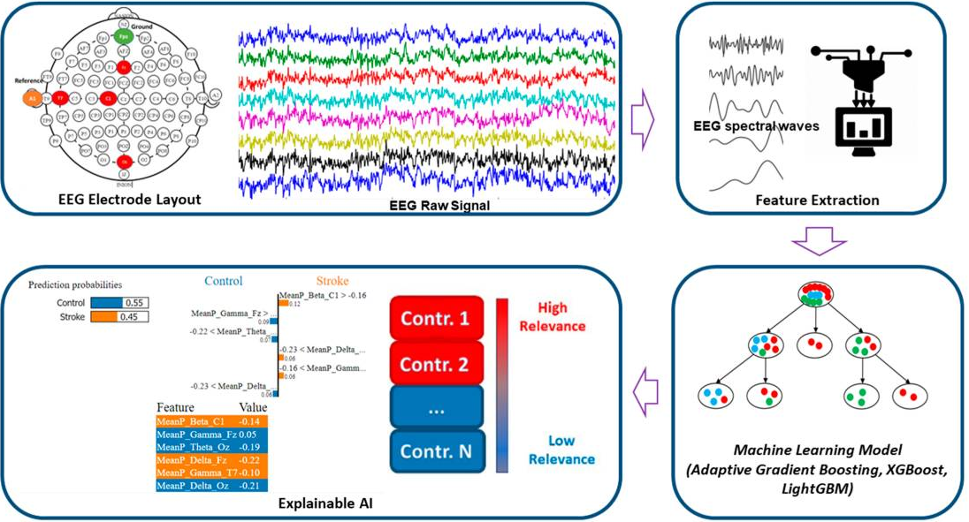

1. The recent development of brain-computer interfaces (BCI) has provided an important element for the creation of brain-to-brain communication systems, and precise brain stimulation techniques are now available for the realization of non-invasive computer-brain interfaces (CBI). These technologies, BCI and CBI, can be combined to realize the vision of non-invasive, computer-mediated brain-to-brain (B2B) communication between subjects (hyperinteraction). The conscious transmission of information between human brains through the intact scalp and without intervention of motor or peripheral sensory systems is demonstrated, such developments have a profound impact on the social structure of our civilization and raise important ethical issues. (Citation #7)

|  |
| --- |
|  |

1. Observing the plight of victims, and the advancements in both invasive and noninvasive overt methodologies in diagnosing, treating, modifying, and controlling brain functions, I strongly suspect that many more advanced covert technologies, such as Directed Energy Weapons, can target specific tissue, organs, without target being aware of external meddling. These technologies can be utilized to target individuals for harassment, social alienation, family disruption, destruction of individual lives, ultimately resulting in disruption of population distribution. These technologies can disrupt human biological homeostasis and influence certain behaviors and outcomes. I strongly believe that safeguarding the fundamental human rights of these victims is paramount. I respectfully request this Hon’ble court to protect the victims, initiate thorough investigations and establish the legal framework required to address technology aided crimes for the better future.

Citations:

1. [WISER NEUROMODULATION PROGRAM - HOME (wiser-program.org)](https://www.wiser-program.org/)
2. https://www.docwirenews.com/post/wireless-neurostimulator-wand-offers-potential-treatment-for-tremors-and-seizures
3. <https://www.enterpriseitworld.com/dassault-systemes-helps-nimhans-improve-medical-treatment-through-neuromodulation/>
4. <https://www.f6s.com/companies/neuroscience/india/co>
5. <https://www.cbinsights.com/research/neurotech-startups-to-watch/>
6. i. <https://stockhead.com.au/tech/brainchip-our-software-design-is-complete-next-stop-brainchips-for-everyone/> ,

ii.https://www.businesswire.com/news/home/20210510005709/en/BrainChip-Demonstrates-Akida-Neuromorphic-Processor-as-Part-of-Data-Science-Week,

iii. [A Comprehensive Guide to Edge AI (xailient.com)](https://xailient.com/blog/a-comprehensive-guide-to-edge-ai/)

1. Conscious Brain-to-Brain Communication in Humans Using Non-Invasive Technologies by Grau et al, 2014. https://www.ncbi.nlm.nih.gov/pmc/articles/PMC4138179/pdf/pone.0105225.pdf
2. [Explainable Artificial Intelligence Model for Stroke Prediction Using EEG Signal - PMC (nih.gov)](https://www.ncbi.nlm.nih.gov/pmc/articles/PMC9782764/), Figure1.

All the above statements are true to the best of my knowledge, and in the interest of justice.

PLACE: Banu Prakash A.S. (MBBS,MS,Mch)

DATE: ADVOCATE: